***TITLE OF SUCCESS STORY:* Lao Red Cross: Working in Partnership with People Living with HIV**

***Agencies names, address and focal contact person: Dr Soulany Chansy, Head of Health, Laos red Cross HQ, Vientiane, csoulany@yahoo.com***

*IMAGES OF THE STORY: Please share as attachment separately high resolution  
(above 1 MB) images to support the success story.*

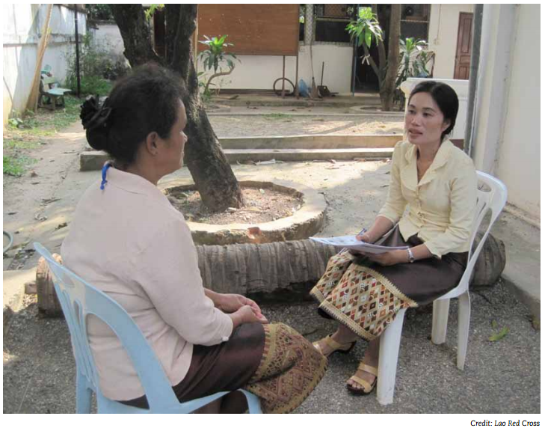

*“I have attended workshops on opportunistic infection and the importance of anti-retroviral treatment, as well as on gender. I now feel I have increased knowledge and skills.” Sompeth, a 33-year-old farmer from Don Ngeun village, Xayaboury district, Xayaboury province, Laos.*

**THE PROBLEM:**

In Lao PDR, there are between 12,000 and 13,000 people living with HIV (PLHIV). HIV-related stigma and discrimination threaten the prevention, treatment and control of HIV and AIDS.

A stigma index survey in Lao PDR found that 23 per cent of all people living with HIV are victims of gossip, 8 per cent lost their jobs due to their HIV status and 4 per cent are discriminated against by co-workers.

The main challenge is limited knowledge of health issues, particularly when it comes to the impact of HIV and AIDS on vulnerable people, and the stigma associated with HIV and AIDS.

**THE ACTIVITIES**

The programme (implemented in six provinces: Luangnamtha, Oudomxay, Xayaboury, Bolikhamxay, Khammoun and Salavan) aimed to:

1. Improve the health and well-being of PLHIV and their families in targeted villages where the programme operates.

2. Create an enabling environment for PLHIV by promoting a rights-based approach, thereby reducing the stigma and marginalization faced by PLHIV.

3. Strengthen the capacity of the Association of PLHIV in Lao (APL+).

The Lao Red Cross support and care programme provides logistical support (such as vouchers for bus tickets) for medical check-ups and access to anti-retroviral drugs for 229 patients (665 requisite medical check-ups), of which 124 are women. PLHIV supported by the project live in remote communities and have no access to treatment due to economic and social constraints. In addition, once every quarter, the Lao Red Cross extends nutrition support for 229 PLHIV. Some beneficiaries of the programme become volunteers in helping other PLHIV to participate in the group and to access care and treatment. The programme also supports the Lao Network of People Living with HIV (LNP+), a young organizaiton with a lack of capacity and financial support. The main activities include strengthening the self-support group of PLHIV, providing technical support for the stigma survey index, and addressing workplace stigma issues. The Lao Red Cross, in collaboration with the Association of PLHIV in Lao, organized a World AIDS Day event, in which 569 students took part with the aim of raising awareness activities for high school students on HIV/AIDS and emphasizing the concept of ‘zero discrimination’.

**THE OUTCOMES**

The Lao Red Cross efforts to promote care and reduce stigma have already had a positive impact on target communities.

The programme’s success is due to the commitment and efforts of Red Cross volunteers, who work directly with PLHIV and their families at grass-roots level.

The beneficiaries which are engaged in helping other PLHIV to access care and treatment will bridge an important gap, providing critical health knowledge to the community and also ensuring equitable access to health services for all.

Furthermore, PLHIV involvement in prevention and care programmes contributes to reducing stigma and discrimination, and results in greater acceptance of PLHIV.

|  |
| --- |
|  |

**WAY FORWARD**

1. The successful implementation of the HIV programme requires support at all levels, including from government, key stakeholders (including PLHIV networks) and local authorities.

2. Regular follow-up and logistical support is essential to ensure adherence to anti-retroviral therapy, as some PLHIV live far from the distribution centre and cannot afford to travel without financial assistance.

3. A voucher system provides a useful way of preventing cash from being misused, and also ensures that PLHIV use this support to get the most out of the service provided.

4. Stigma and discrimination affect women, particularly single women, more than it affects men.

5. Awareness messages, together with the sharing of experiences and success stories, encourage other high-risk people to get tested and to declare their HIV status.

IMPLEMENTING AND PARTNER AGENCIES LOGOS:

