***TITLE OF SUCCESS STORY:* Youth Volunteers Champion Road Safety by Cambodian Red Cross**

***Agencies names, address and focal contact person:* Ms Rasmey Mony LAK, Country Support Plan Coordinator, International Federation of Red Cross and Red Crescent Societies (IFCR) Cambodia Delegation, Phnom Penh, lak.monyrasmey@ifrc.org**

*“I am proud to share road road safety knowledge to distracted riders and drivers, so they can change their risky road behaviours and respect the road traffic law.” - Khem Vuthy, a 10th Grade student in Siem Reap province*

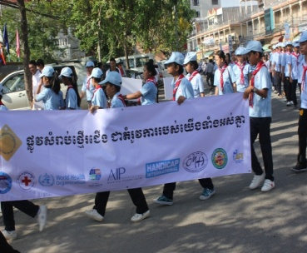

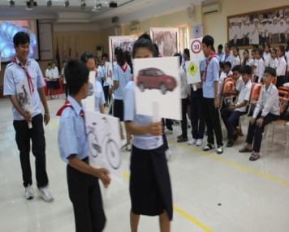

Student Dissemination by Cambodian Red Cross (1)

Dissemination_ Cambodian Red Cross (2)

**THE PROBLEM:**

Since 2005, road-crash deaths have doubled, costing an estimated 310 million US dollars to the Cambodian economy each year.

Motorcyclists are Cambodia’s most vulnerable road users, constituting 66 per cent of total road fatalities. And with two-thirds of the population under the age of 25, young people are disproportionally affected.

**THE OUTCOMES**

As a result of this project, Cambodian Red Cross youth volunteers are experienced in road safety peer education. Also among the key outcomes:

*Distribution of more than 25,000 helmets in local communities.

*Implementation of road safety campaigns in schools. › Establishment of “helmet libraries” in eight schools for low-income students, which increases access to motorcycle helmets. It also has led to a higher rate of helmet wearing among students.

*Mobilization of financial and in-kind resources from private companies as well as contributions from branches to project costs.

*Integration into other programmes such as the Cambodia Initiative for Disability Inclusion (CIDI) and the Global Road Safety Partnership’s Road Safety Advocacy Project.

*Long-term vision and methods to ensure sustainability of the project included from the onset.

*A new traffic law is being processed due to an increased focus on humanitarian diplomacy

**THE ACTIVITIES**

The were four strategic pillars of project activities:

1. Building a culture of helmet wearing (through the strong participation of the Red Cross youth by serving as role models, distribution of helmets, establishment of helmet libraries and information dissemination on correct use of helmets and the value of helmet protection

2. School-based road safety campaigns (Red Cross youth volunteers leading peer education)

3. Community-based education (Cambodian Red Cross youth and volunteers partnering with traffic police to disseminate information on road safety to drivers at enforcement checkpoints)

4. Building capacity, support and partnerships (Cambodian Red Cross builds partnership with private companies and the Global Road Safety Partnership, also leveraging their auxiliary status to influence decision-makers to strengthen road safety laws).

The Cambodian Red Cross also partners with Australian Red Cross in order to integrate disability into road safety programs. Young people with disabilities (often the results of road accidents) are actively involved in designing and implementing project activities, rather than being “targets” of the project.

|  |
| --- |
|  |

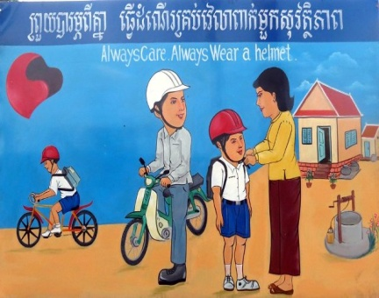

Example of Information and Education materials by CRC

**WAY FORWARD**

The Cambodian Red Cross road safety project is one of the most successful examples of long-term road safety initiatives in the Red Cross Red Crescent Movement today.

The project demonstrates that youth and volunteers can be empowered to play a role in positively influencing mindsets, attitudes, and behaviours around the use of helmets to reduce death and injury on the road.

More information at <http://bit.ly/1aIlVWg>

IMPLEMENTING AND PARTNER AGENCIES LOGOS: 