***TITLE OF SUCCESS STORY:* Classroom Learning Empowers Students and Community in Yangon, Myanmar**

***Agencies names, address and focal contact person:* Mr Maung Maung Khin, Head of Disaster Management, Myanmar Red Cross HQ, Yangon,mmk.mrcs@gmail.com**

*IMAGES OF THE STORY: Please share as attachment separately high resolution(above 1 MB) images to support the success story.*

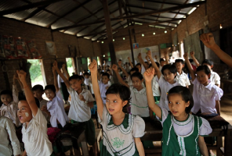 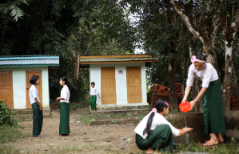

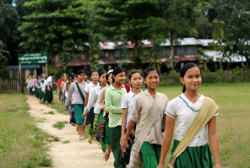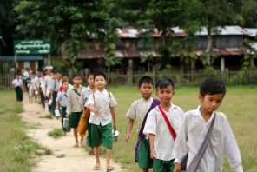

All photos are © Felix La Framboise

*"We did not know earlier that we needed to clean our hands, food, water and toilets. The Red Cross shared knowledge of personal hygiene, cleanliness and how we can get an infection If we fail to clean, we may be infected through our hands. I am happy that I am able to apply my knowledge which I received from the Red CRoss training in my daily life, which is very useful for me. I am so proud that I have the chance to share my knowledge to others especially to my family members and neighbours." Ma Khine Thazin, 13 years old, Grade 7 student.*

**THE PROBLEM:** While the area of South Dagon Township, Yangon, is fairly protected from disaster, the community needed to build its preparedness, to protect lives and livelihoods in the event that disaster strikes.

**THE OUTCOMES**

*Knowledge was passed on from students to their parents and families, and collectively, they were able to apply the knowledge learned to their daily lives, particularly with reards to sanitation.

*Students, teachers and wider community were better prepared for potential disasters, for example floods.

*Students have integrated their knowledge on how to respond to a flood, earthquake, cyclone, etc into their daily games and playing. Furthermore, students are engaged in peer-to-peer education, with older students passing on the things they learned to younger students.

**THE ACTIVITIES**

Myanmar Red Cross organized disaster preparedness trainings, first aid and hygiene promotion trainings, as well as regular weekly simulations with teachers, in order to promote school based disaster risk reduction.

These activities were conducted under the Myanmar Red Cross’ Urban Disaster Risk Reduction Programme.

|  |
| --- |
|  |

**WAY FORWARD**

Risk reduction education in schools helps to build community resilience. Young people take their risk reduction skills beyond the schoolhouse, to reach their families, friends and community.

It is important we recognise and invest in them. And indeed, Myanmar Red Cross is continuing to place an emphasis on education and the role of young people in developing safer communities.

IMPLEMENTING AND PARTNER AGENCIES LOGOS:

