***TITLE OF SUCCESS STORY:* Women Firefighters Help Build Safer Communities – A Success Story on Women’s Empowerment and Disaster Risk Reduction from Myanmar Red Cross**

In

***Agencies names, address and focal contact person:* Mr Maung Maung Khin, Head of Disaster Management, Myanmar Red Cross HQ, Yangon,mmk.mrcs@gmail.com**

*IMAGES OF THE STORY: Please share as attachment separately high resolution (above 1 MB) images to support the success story.*

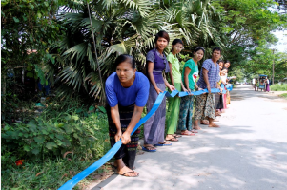 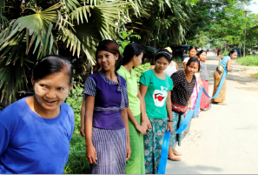

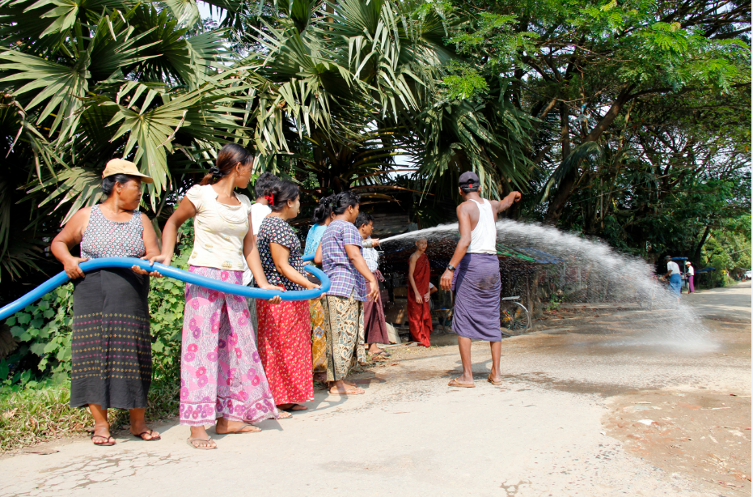

All photos ©Mandy George / IFRC

*"A fire occurred two years ago. Many houses burnt down during that fire and there were not enough people to fight the fire in a timely manner. Most people didn’t have disaster knowledge. Last year, the Red Cross gave us trainings on disaster knowledge, and health education, including how to fight a fire." I was glad to participate in it... Now we know well how to prepare, how to face, how to respond and what to do during such situations [floods, earthquakes, fires, cyclones etc]. ....Now we have the self-confidence to prevent, prepare, and face a fire." Ma San Wai, newly trained firefighter.*

**THE PROBLEM:**

The community of 21st ward of South Dagon Township, Yangon has a lack of knowledge on how to act during disasters, particularly during fires.

Coupled with the absence of able-bodied men who leave the ward to go to the market to look for work during the day (as casual labourers, masons, carpenters etc), the vulnerability of the community to fires is heightened.

*IMAGES OF THE STORY: Please share as attachment separately high resolution (above 1 MB) images to support the success story.*

*IMAGES OF THE STORY: Please share as attachment separately high resolution (above 1 MB) images to support the success story.*

|  |
| --- |
| **THE OUTCOMES**  Women in the community are now equipped with the knowledge on how to prevent, prepare and face a fire. Owing to this program, the community is safer and more resilient. |

IMPLEMENTING AND PARTNER AGENCIES LOGOS:

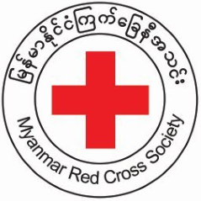

**WAY FORWARD**

This activity may be replicated to build the resilience of similar communities in Myanmar but also in other countries.

Woment truly play a key part in building the safety and resilience of their communities. In fact, because of their roles and responsibilities, sometimes they are best placed to play a leading role in protecting their communities.

**THE ACTIVITIES**

In response to the problem, Myanmar Red Cross delivered a training on disaster knowledge, including what to do during and after disasters, such as floods, earthquakes, fires, and cyclones.

The training included a session for women on how to fight fires. Most women in the ward attended the training and found confidence to act in emergency caused by fires.