***TITLE OF SUCCESS STORY:* Reaching Out to the New Generation – A Story of Success of Youth in Building Community Resilience, from Myanmar Red Cross**

***Agencies names, address and focal contact person:* Mr Maung Maung Khin, Head of Disaster Management, Myanmar Red Cross HQ, Yangon,mmk.mrcs@gmail.com**

*"Many families in the past used traditional methods to cure a nose bleed, such as inhaling cow manure or using chalk powder. Now the parents ask us about our first aid when they come to pick up their children from school and we are able to share with them. More and more parents come to discuss first aid or disaster preparedness with us every year and they are starting to abandon their traditional practices and take on this new learning." Daw Naw San Nyein, a teacher in Ywar Thit Primary School in Thone Gwa Township, Myanmar.*

*IMAGES OF THE STORY: Please share as attachment separately high resolution(above 1 MB) images to support the success story.*

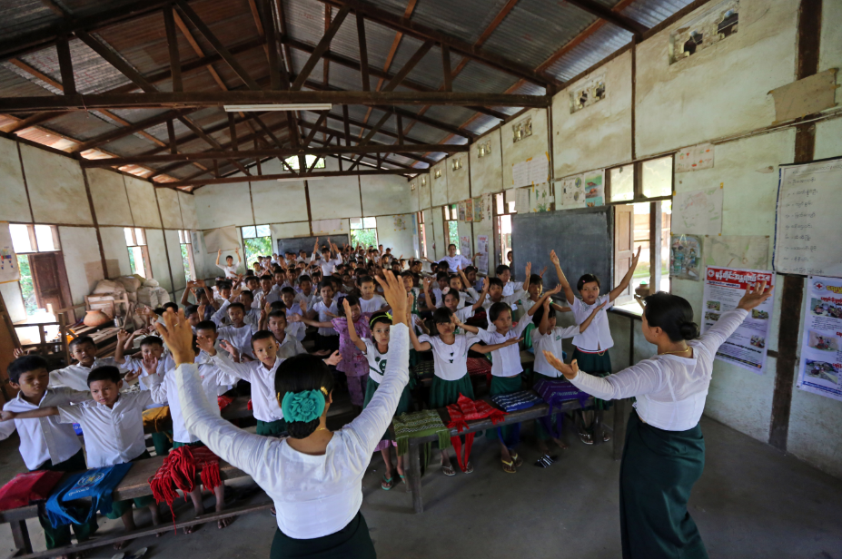

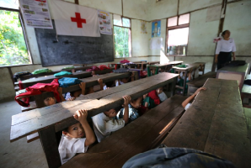

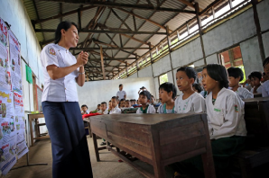

All photos © Felix La Framboise

**THE PROBLEM:**

Many communities in Myanmar are not disaster-prepared, rendering them vulnerable. Such is particularly the case in Thone Gwa Township, Myanmar.

*IMAGES OF THE STORY: Please share as attachment separately high resolution (above 1 MB) images to support the success story.*

*IMAGES OF THE STORY: Please share as attachment separately high resolution (above 1 MB) images to support the success story.*

|  |
| --- |
| **THE OUTCOMES**  Teachers are able to better create a safe learning environment for the children, while also sharing disaster preparedness knowledge which can be passed on to the students and their families.  This affects a positive change in perceptions and behavior, rendering the communities more disaster resilient through the outreach to the young generation. |

**WAY FORWARD**

The young generation and their teachers are important agents of change. Through them, community empowerment to disaster resilience is truly possible.

Myanmar Red Cross is continuing to place an emphasis on education and the role of young people in disaster rsik reduction and building safer communities.

IMPLEMENTING AND PARTNER AGENCIES LOGOS:

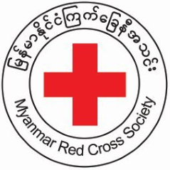

**THE ACTIVITIES**

Myanmar Red Cross Society provided school teachers and students with essential skills in delivering first aid, in order to reach promptly whenever needed.

Myanmar Red Cross Society also trained (and continues to train) teachers across the country in disaster preparedness, using role-play, poems and songs to help children to understand what to do in the event of an earthquake, cyclone or floods.