***TITLE OF SUCCESS STORY:* The Impact of Disaster Risk Reduction Field Sessions in Myanmar – A Success Story from Myanmar Red Cross**

***Agencies names, address and focal contact person:* Mr Maung Maung Khin, Head of Disaster Management, Myanmar Red Cross HQ, Yangon,mmk.mrcs@gmail.com**

*IMAGES OF THE STORY: Please share as attachment separately high resolution  
(above 1 MB) images to support the success story.*

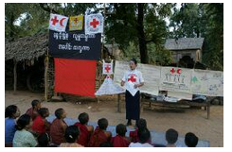

*©* Thorkell Thorkelsson/Islandic Red Cross

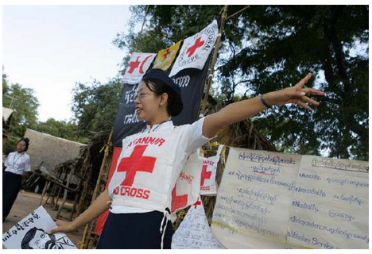

*©* Thorkell Thorkelsson/Islandic Red Cross

*“In our community, we have a canal that was polluted with rubbish and weeds. After the DRR field session, we organized the community to dig out and clean the canal [...] We also cleaned the drainage system and encourage people to dispose of their rubbish in the proper place so that we can minimize any health problems. We contacted the township authority and explained our problems. The local authority provided equipment to clean the drainage system, and members of the community cleaned it on their own initiative. Thein Chaung community is clean now,” Daw Theingi Htwe, a member of the ward DRR committee and chairperson of the first aid committee of Ward 21 of New Dagon (South), Yangon.*

**THE PROBLEM:**

Communities in Yangon are highly exposed to the risk of fire and flooding, as well as to other health-related risks, such as dengue, tuberculosis and hygiene-related issues. They are also ill equipped with little knowledge of disaster risk reductions they can take.

*IMAGES OF THE STORY: Please share as attachment separately high resolution (above 1 MB) images to support the success story.*

**THE ACTIVITIES**

Over ten days, community volunteers from Myanmar Red Cross Society, IFRC and partner National Societies were trained in disaster risk reduction – in actual community settings - engaging in practical work, group activities and theory.

The process promoted peer learning and enhanced the development of skills based on theory and reality.

Participants were exposed to a case study and a real-life situation – one that placed participants directly in contact with a community that needs assistance.

The participants conducted collective multi-sector risk assessment practices – drawn from integrated programming and reinforced with practical activities and structured theory – in order to strengthen existing skills in the community.

By working with a real community, participants learned how to maximize Red Cross Red Crescent contributions to improving livelihoods, water and sanitation, health and care, and DRR. Eventually, when participants became active practitioners, they were able to prepare their own National Society to implement effective resilience activities.

|  |
| --- |
|  |

**THE OUTCOMES**

The field sessions benefited communities in implementing disaster risk reduction, and also enhanced the skills and knowledge of Red Cross staff in DRR.

The Myanmar Red Cross continues to work with the core staff trained during the field sessions, to train additional staff and volunteers on DRR.

**WAY FORWARD**

Discussions to develop a standard manual for disaster risk reduction in field schools is well under way.

It will include a clear outline on the processes and tools so that it will be easy for not only Myanmar Red Cross Society, but for other National Societies in Southeast Asia to implement field schools at the branch and community level. The goal would be to further complement this manual with a simple but visual aid to reach wider audiences – such as a comic or animation - which demonstrates how to utilise common assessment tools, and in the future, creation of a global tool.

IMPLEMENTING AND PARTNER AGENCIES LOGOS:

