***TITLE OF SUCCESS STORY:* Mangrove Plantation in Viet Nam: Measuring Impact and Cost Benefit – A Success Story from Viet Nam Red Cross**

***Agencies names, address and focal contact person:* Mr. Dang Minh Chau, Deputy Secretary-General, Viet Nam Red Cross HQ, 82 Nguyen Du Street Hanoi, chauvrc@gmail.com**

*QUOTE FROM LOCAL COMMUNITY MEMBER INVOLVED IN THE PROJECT*

*IMAGES OF THE STORY: Please share as attachment separately high resolution  
(above 1 MB) images to support the success story.*

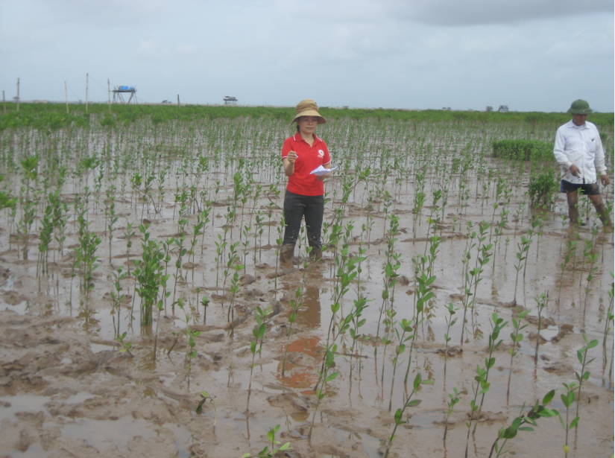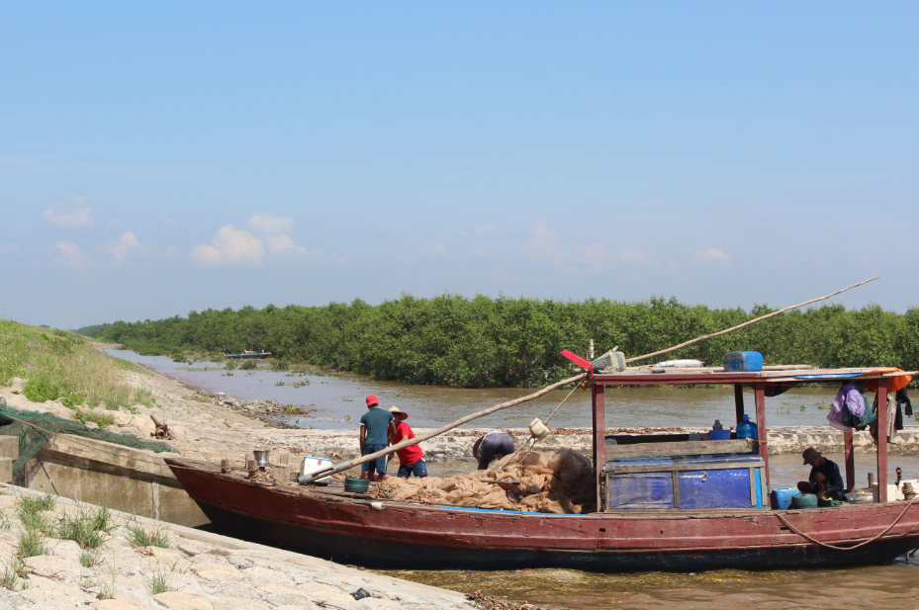 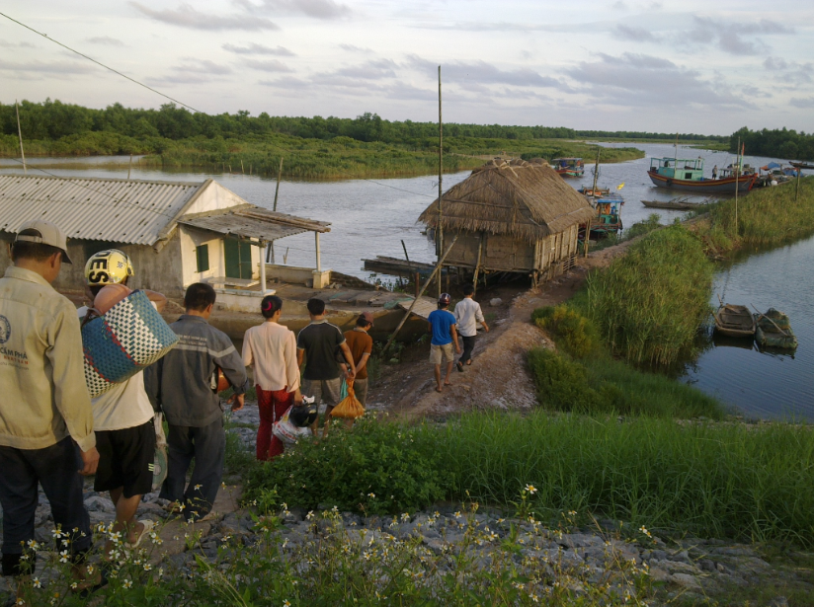

© Viet Nam Red Cross

**THE PROBLEM:** *Viet Nam, with its 3,260 kilometres (km) of coastline is vulnerable to natural disasters including storm surges, flooding and droughts. Extreme climate variability increasingly threatens the country’s coastal zones and extensive deltas. Viet Nam has a history of coping with extreme weather-related events, and is ranked amongst the most affected countries, both in terms of fatalities and economic losses.It is estimated that the country faces an average of six to eight typhoons annually– causing fatalities and wreaking havoc on infrastructure and the population’s livelihoods. Climate-related vulnerabilities are key factors in undermining the country’s sustained efforts in reducing poverty.*

*It is projected that the sea level in Viet Nam’s coastal regions will rise between 65 to 100 centimetres by 2100. These projections are further supported by a recent report by the Intergovernmental Panel on Climate Change projecting an increase in sea levels along coastal areas due to climate variability.The impact on the coastal population from a one meter sea-level rise will be quite severe. It is projected that by 2100, 4.4 per cent of Viet Nam’s coastal areas will be inundated, directly affecting six million people (7.3 per cent of the country’s population).*

*The coastal provinces in northern Viet Nam face a number of great challenges. Exposure to climate-related disasters and rising sea levels poses significant threats to and underlines the existent vulnerabilities of the coastalregions. This vulnerability is compounded by rapid population growth, coastal modifications and extensive land-use changes such as agricultural intensification and expansion, wetland conversion and urbanization, issues which were precipitated by the introduction of the Doi Moi, a series of economic reforms, in 1986. The Doi Moi, heralded substantial economic growth, notably, the period between 1990 to 2004 witnessed a tripling of the country’s gross national product and saw the percentage of poor households decrease from 58 per cent in 1994 to 24 per cent in 2004. However, it should be noted that certain economic liberalization paradigms also propelled a significant decrease in mangrove forests to make way for the establishment of shrimp farms as well as for industrial and urbanization projects. This rapid expansion has had detrimental effects on the environment. The adverse environmental effects continue to be exacerbated by the increasing frequency of natural disasters in Asia, and the projected long-term impact of climate change, including increases in storms and sea-level rise.*

*Mangrove forests provide essential functions and services to coastal communities. These include acting as carbon sinks thereby mitigating the effects of climate change, providing nutrients for marine life and enhancing protection to coastal communities from associated storm surges and erosion, by capturing soil during periods of heavy precipitation thus stabilizing shoreline sediments.*

*Additionally, “mangroves serve as a nursery and breeding ground for many reef organisms,” while they have also been sustainably used “for food production, medicines, fuel wood and construction materials.” In an attempt to mitigate the impact of disasters, restoration and rehabilitation of mangrove forests have been a central focus of both governmental and non-governmental actors in the region. Afforestation was seen as a means to combat the loss of natural coastal protection by safeguarding sea dykes, reducing the risk of flooding and protecting livelihoods.*

**THE OUTCOMES**

The evaluation’s findings note that globally the project has had a significant impact both towards a reduction of disaster risk and an enhancement of communities’ livelihoods.

It is estimated that approximately 350,000 beneficiaries were reached directly by the project’s intervention, while another two million were indirectly protected through the afforestation efforts. Comparing the damage caused by similar typhoons before and after the intervention, the evaluation has found that damages to dykes have been reduced by CHF 73,000 (USD 80,000/EUR 59,000) to CHF 270,000 (USD 295,000/EUR 218,000) – savings which represent less than the costs for mangrove planting. However, total savings due to avoided risksnin the communities at large were found to be quite substantial, standing at approximately CHF 13.7 million (USD 15 million/EUR 11 million).

Mangroves have also had a positive impact on the provision of additional income for coastal communities through an increase in per hectare yield of aqua culture products such as shells and oyster by 209-789 per cent. Direct economic benefits from aqua product collection, honeybee farming, etc., are found to be between CHF 310,000 (USD 344,000/EUR 250,000) to CHF six million (USD 6.7 million/EUR 4.8 million) in the selected communes.

The significant ecological benefits of the project should be noted – the present value of estimated minimum CO2 emissions absorbed by the planted mangrovesnstands at CHF 196 million (USD 218 million/EUR 159 million), assuming a price of USD 20/t CO2e.

With regard to sustainability, the evaluation notes that there is strong local ownership towards plantation and maintenance of mangrove forests. Equally, there is strong support and commitment on the part of the government to sustain these efforts. However, specific challenges to long-term sustainability include the need for greater coordination for long-term planning between the VNRC, the Ministry of Agriculture and Rural Development and the Ministry of National Resources and Environment. Moreover, there is a need for the VNRC to improve the capabilities of staff and volunteers.

**THE ACTIVITIES**

The Viet Nam Red Cross (VNRC) has been at the forefront of these activities since 1994, when its Thai Binh chapter launched the community-based MP/ DRR project with the support of the Danish Red Cross (DRC). By 1997, after a series of successes the project was expanded to include another seven coastal provinces in northern Viet Nam. In support of VNRC’s implementation of the project, the DRC expanded its coverage to Nam Dinh province, while the Japanese Red Cross (JRC) initiated funding to six provinces (Ha Tinh, Hai Phong, Nghe An, Ninh Binh, Thanh Hoa and Quang Ninh) through the IFRC. By the early 2000s, the project’s focus was broadened to include disaster preparedness training and afforestation with bamboo and casuarina trees in communes along rivers. In 2005, DRC finished its part of the project, and JRC has funded activities in all eight provinces since.

|  |
| --- |
|  |

IMPLEMENTING AND PARTNER AGENCIES LOGOS:



**WAY FORWARD**

Mangroves have proved to protect dykes and coastal communes well– the added protection for private assets, in particular those located betweennmangroves and dykes, is found to be extremely valuable. The project is seen as highly efficient in that it has generated benefits in great excess of its costs.

Mangrove afforestation is seen as a comparably more efficient way to protect coastal communes than other tools – not only because it is cheaper per se, but also because it offers benefits other tools fail to offer (direct economic and ecological benefits, protective benefits for assets located outside the sea-dyke). The community-based MP/DRR project has led to remarkable achievements that improved the protection of dykes and left coastal communities better prepared to cope with disasters. The fact that more than a quarter of all existing mangroves in the eight northern provinces are due to the VNRC project speaks for itself. Mangrove afforestation can be an efficient and effective tool for disaster mitigation and enhanced livelihood as well as for the mitigation of climate change.

Source: http://www.ifrc.org/Global/Publications/disasters/reducing_risks/Case-study-Vietnam.pdf