***TITLE OF SUCCESS STORY:* Transitional Shelter - Bamboo Houses.**

**Building community *and* houses, using bamboo – a story of success from Indonesian Red Cross (Palang Merah Indonesia)**

***Agencies names, address and focal contact person:* ARIFIN M. HADI Head of Disaster Management Division, Indonesian Red Cross National Headquarter Ph: +62 21 7992325 E-mail: Arifin_mhadi@pmi.or.id**

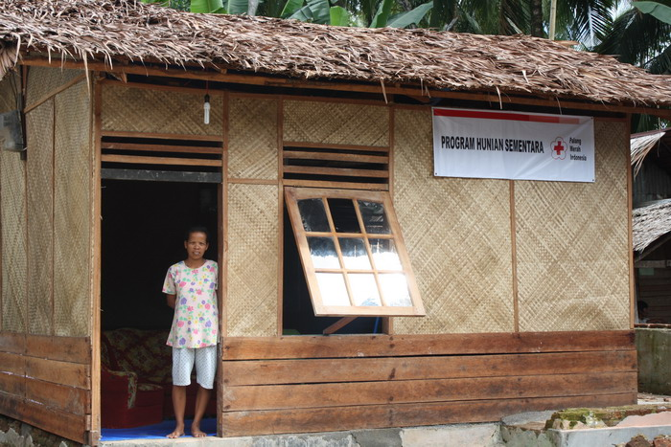

Photo by Rifky – Indonesian Red Cross

*“My house was badly damaged at that time, so I had to sleep in a tent. After sleeping here for three months, I heard about the bamboo house donation from PMI. Thoses houses were really built within a week. It did't take a very long time because the whole community association (Rukun Tetangga/RT) helped in the construction," recalled Wati, one of Mbah Rumini children.*

**THE PROBLEM:**

Following the 2006 earthquake in Yogyakarta and Central Java, tens of thousnads of building were reduced to rubble.

In the early recovery phase of a disaster, providing safe and appropriate temporary shelter reduces the level of a wide range of health risks, to which the displaced are vulnerable.

It also provides an acceptable home base and a sense of security to rebuild and resume livelihoods and normal economic activities.

**THE ACTIVITIES**

In the areas affected by the 2006 earthquake in Yogyakarta and Central Java, PMI helped communities to construct over 12,000 tempoary bamboo shelters for people whose homes were destroyed or heavily damaged by the earthquake.

The project not only provided around 50,000 vulnerable people with earthquake resistant temporary shelters (that could be used for up to two years), but also strengthened community resilience through the use of "gotong royong", community mechanisms for managing the whole process of purchase of materials and contrsuction of the bamboo shelters.

Learning from previous experience, the Indonesian Red Cross (PMI) decided to provide transitional shelters to community members immediately after a major earthquake in March 2007 in the three districts of Agam, Solok, and Tanah Datar in West Sumatra.

Taking into consideration that transitional shelters should be easily built, environmentally friendly and relatively resilient to eathquakes, loacal bamboo (already a familiar item to the communities) was selected as the primary building material. Throughout the operation, PMI provided bamboo, tarpaulin, palm fibre rope, toolkits, and some cash aid to each household, and local people helped one another with construction work. As a result, 1,430 transitional houses were constructed by the end of November 2007.

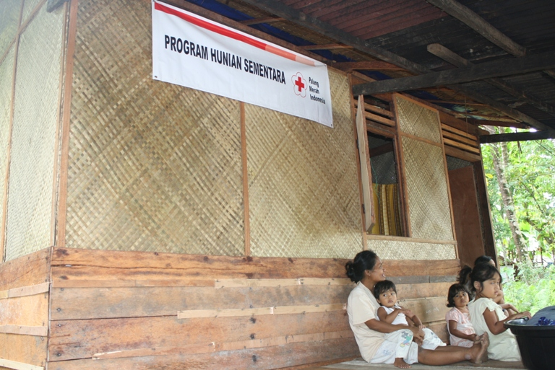

Photo by Rifky – Indonesian Red Cross

|  |
| --- |
|  |

**THE OUTCOMES**

These bamboo houses have become "a permanent home" for the quake-affected people since they know exactly the benefits of these houses.

IMPLEMENTING AND PARTNER AGENCIES LOGOS:

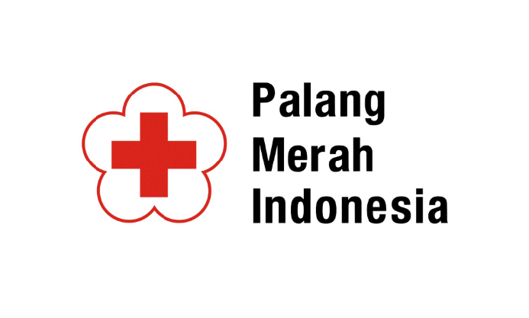

**WAY FORWARD**

Bamboo houses are safe building to livein, especially for those who live in earthquake prone areas.

A guideline of making bamboo house has been produced by the Indonesian Red Cross in collaboration with several national and international agencies. These guidelines have been shared, especially among areas that have similar threats. Since bamboo habitat is very common in most area in the country, the replication of this shelter is feasible.

Source: Page 147, 'Light Up: Indonesian Red Cross contribution towards the Hyogo Framework for Action 2005-2015'