***TITLE OF SUCCESS STORY:* Avian Influenza Awareness Campaign – A success story in pandemic preparedness from Indonesian Red Cross (Palang Merah Indonesia)**

***Agencies names, address and focal contact person:* ARIFIN M. HADI Head of Disaster Management Division, Indonesian Red Cross National Headquarter Ph: +62 21 7992325 E-mail: Arifin_mhadi@pmi.or.id**

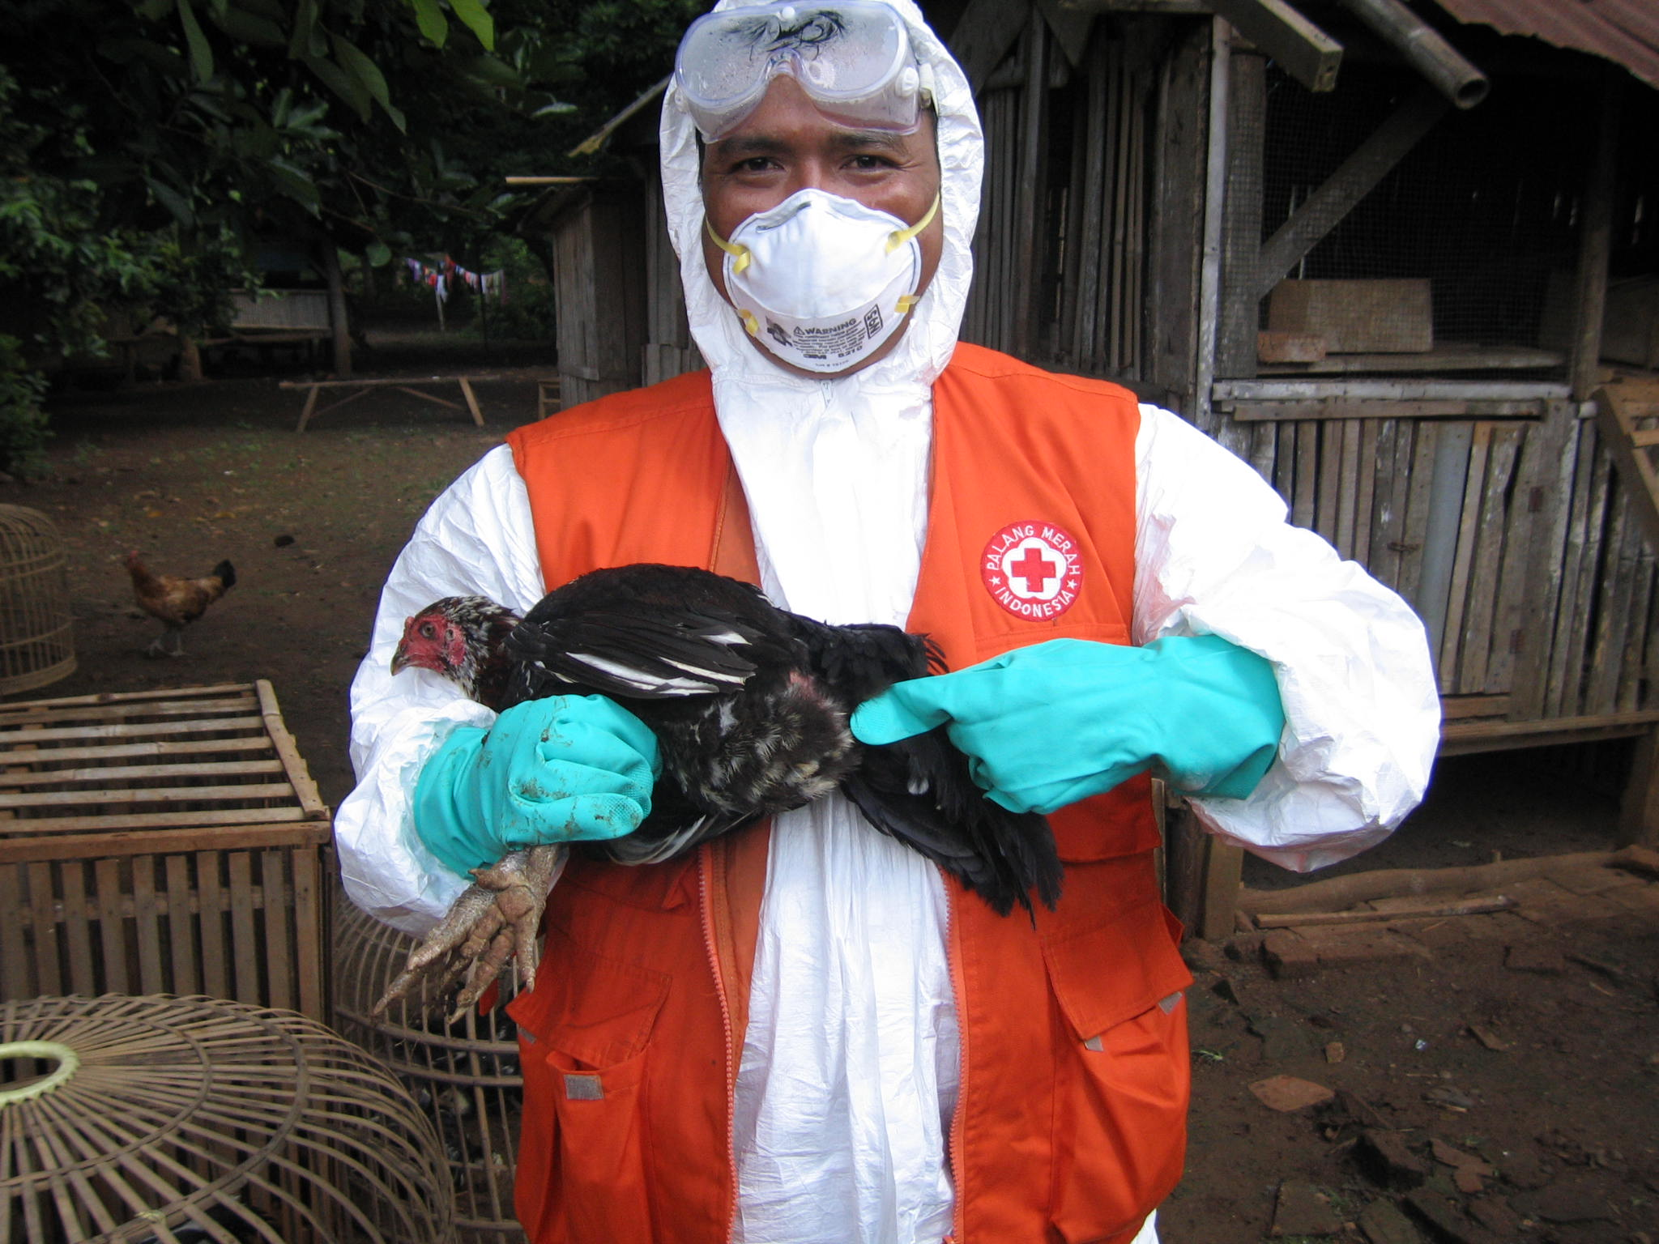

Indonesian Red Cross volunteer

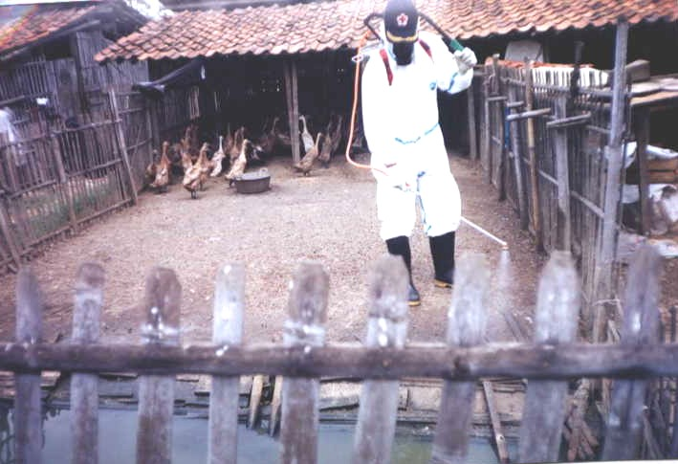

Avian Influenza campaign by Indonesian Red Cross

Photos © Indonesian Red Cross (PMI)

*"I have moved the chicken cage to be exposed by the sun and always remember to clean it regularly as suggested by my village volunteer friends," says Deden Romli, who has been raising chickens in his backyard for 15 years.*

**THE PROBLEM:**

Indonesia has the highest number of reported deaths from avian influenza (AI).

To prevent a future pandemic, PMI began the community-based avian influenza control project in 2006, targeting more than 400,000 people in ten provinces where AI cases were reported.

The objective was to increase awareness of avian influenza and reduce the risk of a pandemic by sharing knowledge across communities.

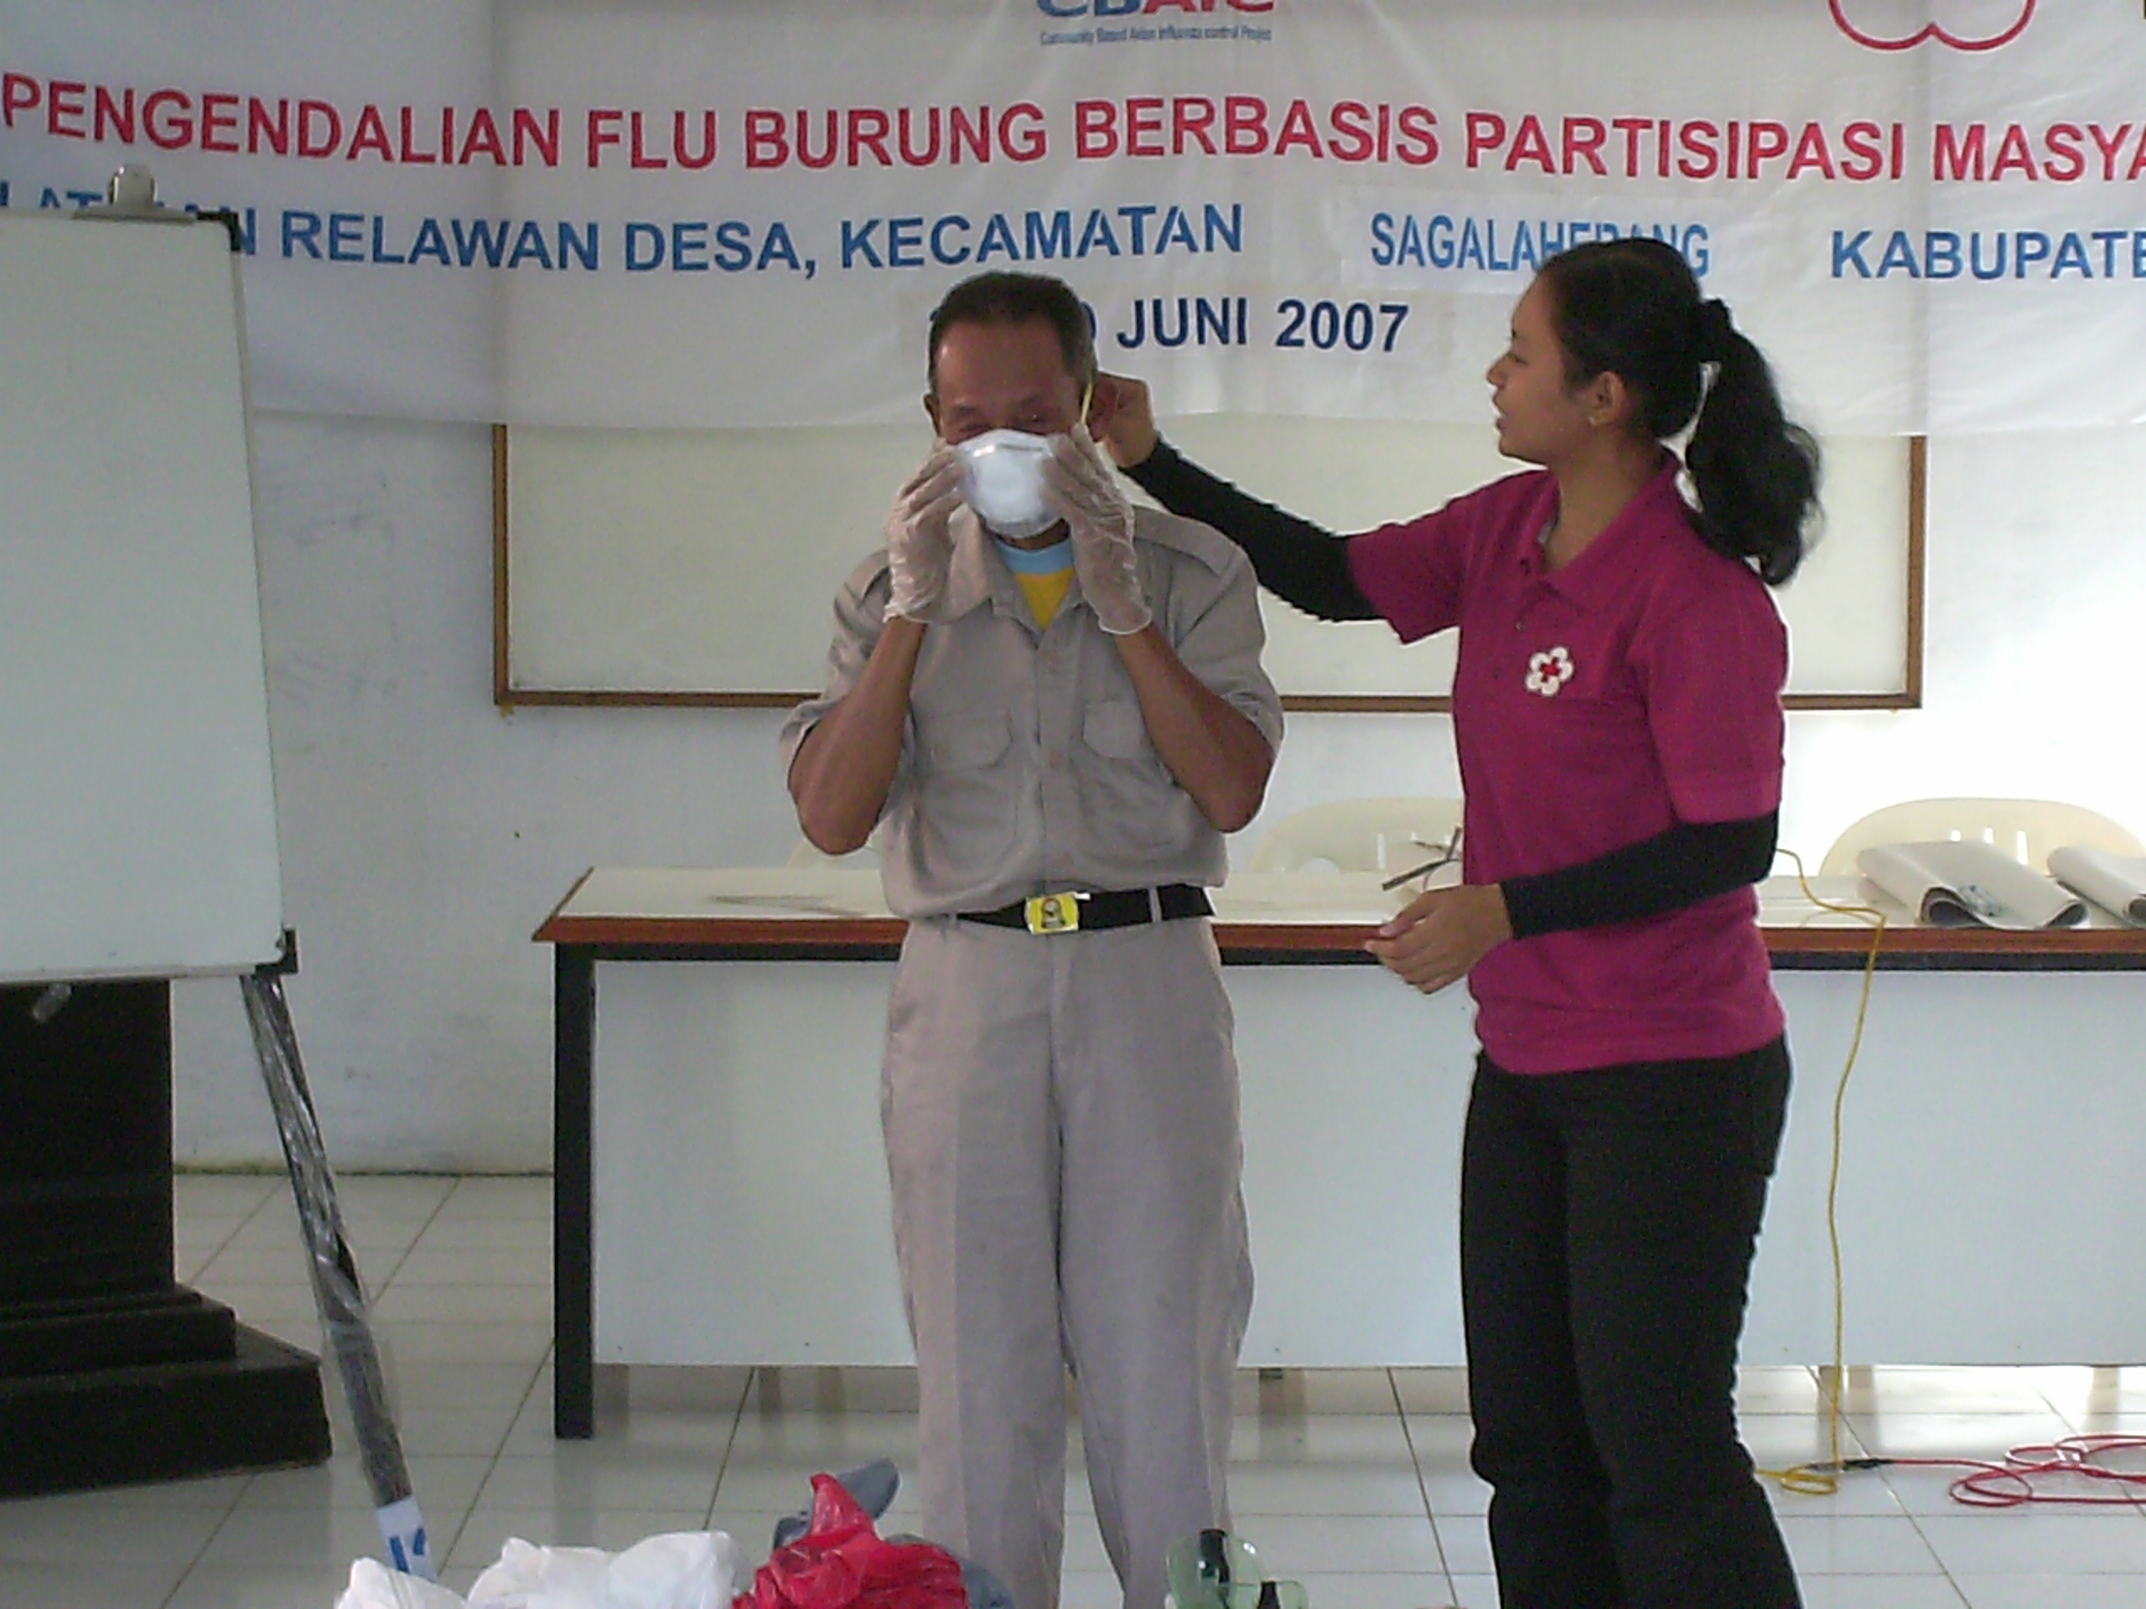

Avian Influenza campaign by Indonesian Red Cross

**THE ACTIVITIES**

In the target villages, PMI recruited and trained village coordinators to provide training to community volunteers, regarding how to disseminate knowledge on avian influenza. Specifically to the four target groups of households, poultry framers, schools, and traditional markets.

Different approaches were used for each group. For example, in the case of households, volunteers made door-to-door visits and used materials such as flyers, flipcharts, posters and stickers.

At first people were wary of the campaign because of their fears of avian influenza in general; however, once they understood the necessity of prevention, they were receptive to awareness activities.

At the national level, a number of workshops were held so that PMI branch staff could train local volunteers and partners. Educational DVDs for avian influenza prevention were produced in November 2007 and distributed to all PMI branches nationwide.

|  |
| --- |
|  |

**THE OUTCOMES**

As a result of the community education efforts, poultry farmers reported several cases of avian influenza infection to the authorities because they had a better understanding of thedisease.

Sustained positive behavioural changes in people's routines, such as hand washing and improved poultry keeping practices, were also achieved through this campaign.

IMPLEMENTING AND PARTNER AGENCIES LOGOS:

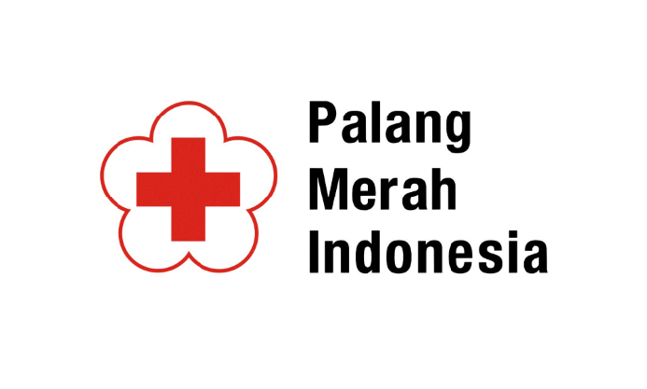

**WAY FORWARD**

Although the program has ended, the villagers still practice a healthy lifestyle. Spreading a healthy lifestyle turned out to be the key to preventing this communicable disease.

Source: Page 140, 'Light Up: Indonesian Red Cross contribution towards the Hyogo Framework for Action 2005-2015'