***TITLE OF SUCCESS STORY:* Community Ownership in the Flow of Water – A story of success from the indonesian red cross (palang Merah indonesia)**

***Agencies names, address and focal contact person:* ARIFIN M. HADI Head of Disaster Management Division, Indonesian Red Cross National Headquarter Ph: +62 21 7992325 E-mail: Arifin_mhadi@pmi.or.id**

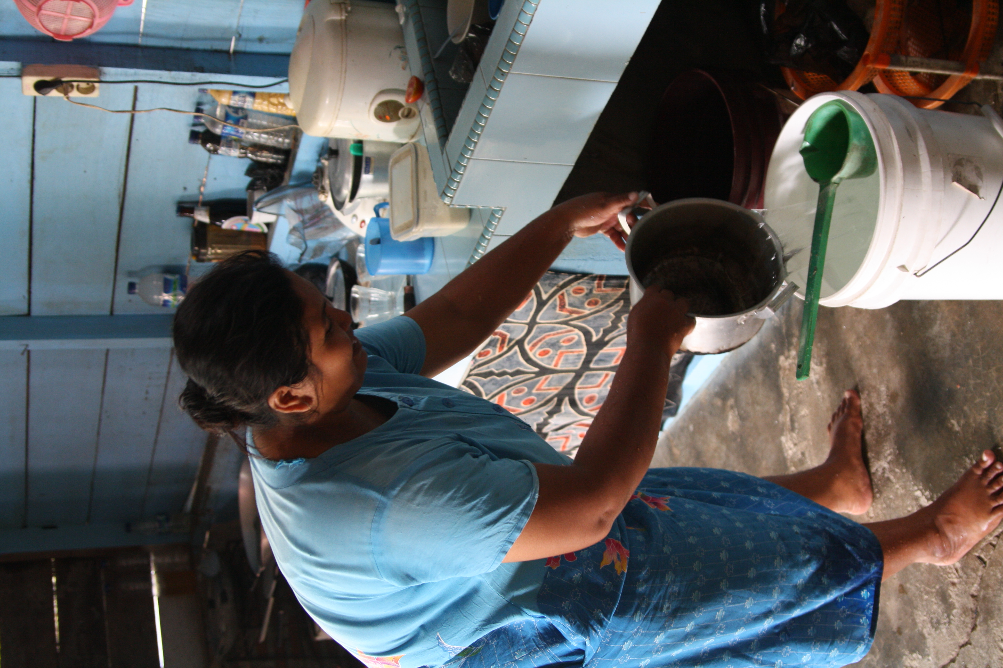

Clean water in Aceh Barat © Indra Yogasara

*"We never dared to dream the water would flow in our village like today." Syakban Siregar, the head of Mata Ie Alue Pochik, a local community organization which manages clean water distribution in the area.*

**THE PROBLEM:**

National water networks do not reach the sub-district of Kruen Raya, Aceh Besar District, Aceh Besar Regency, Indonesia.

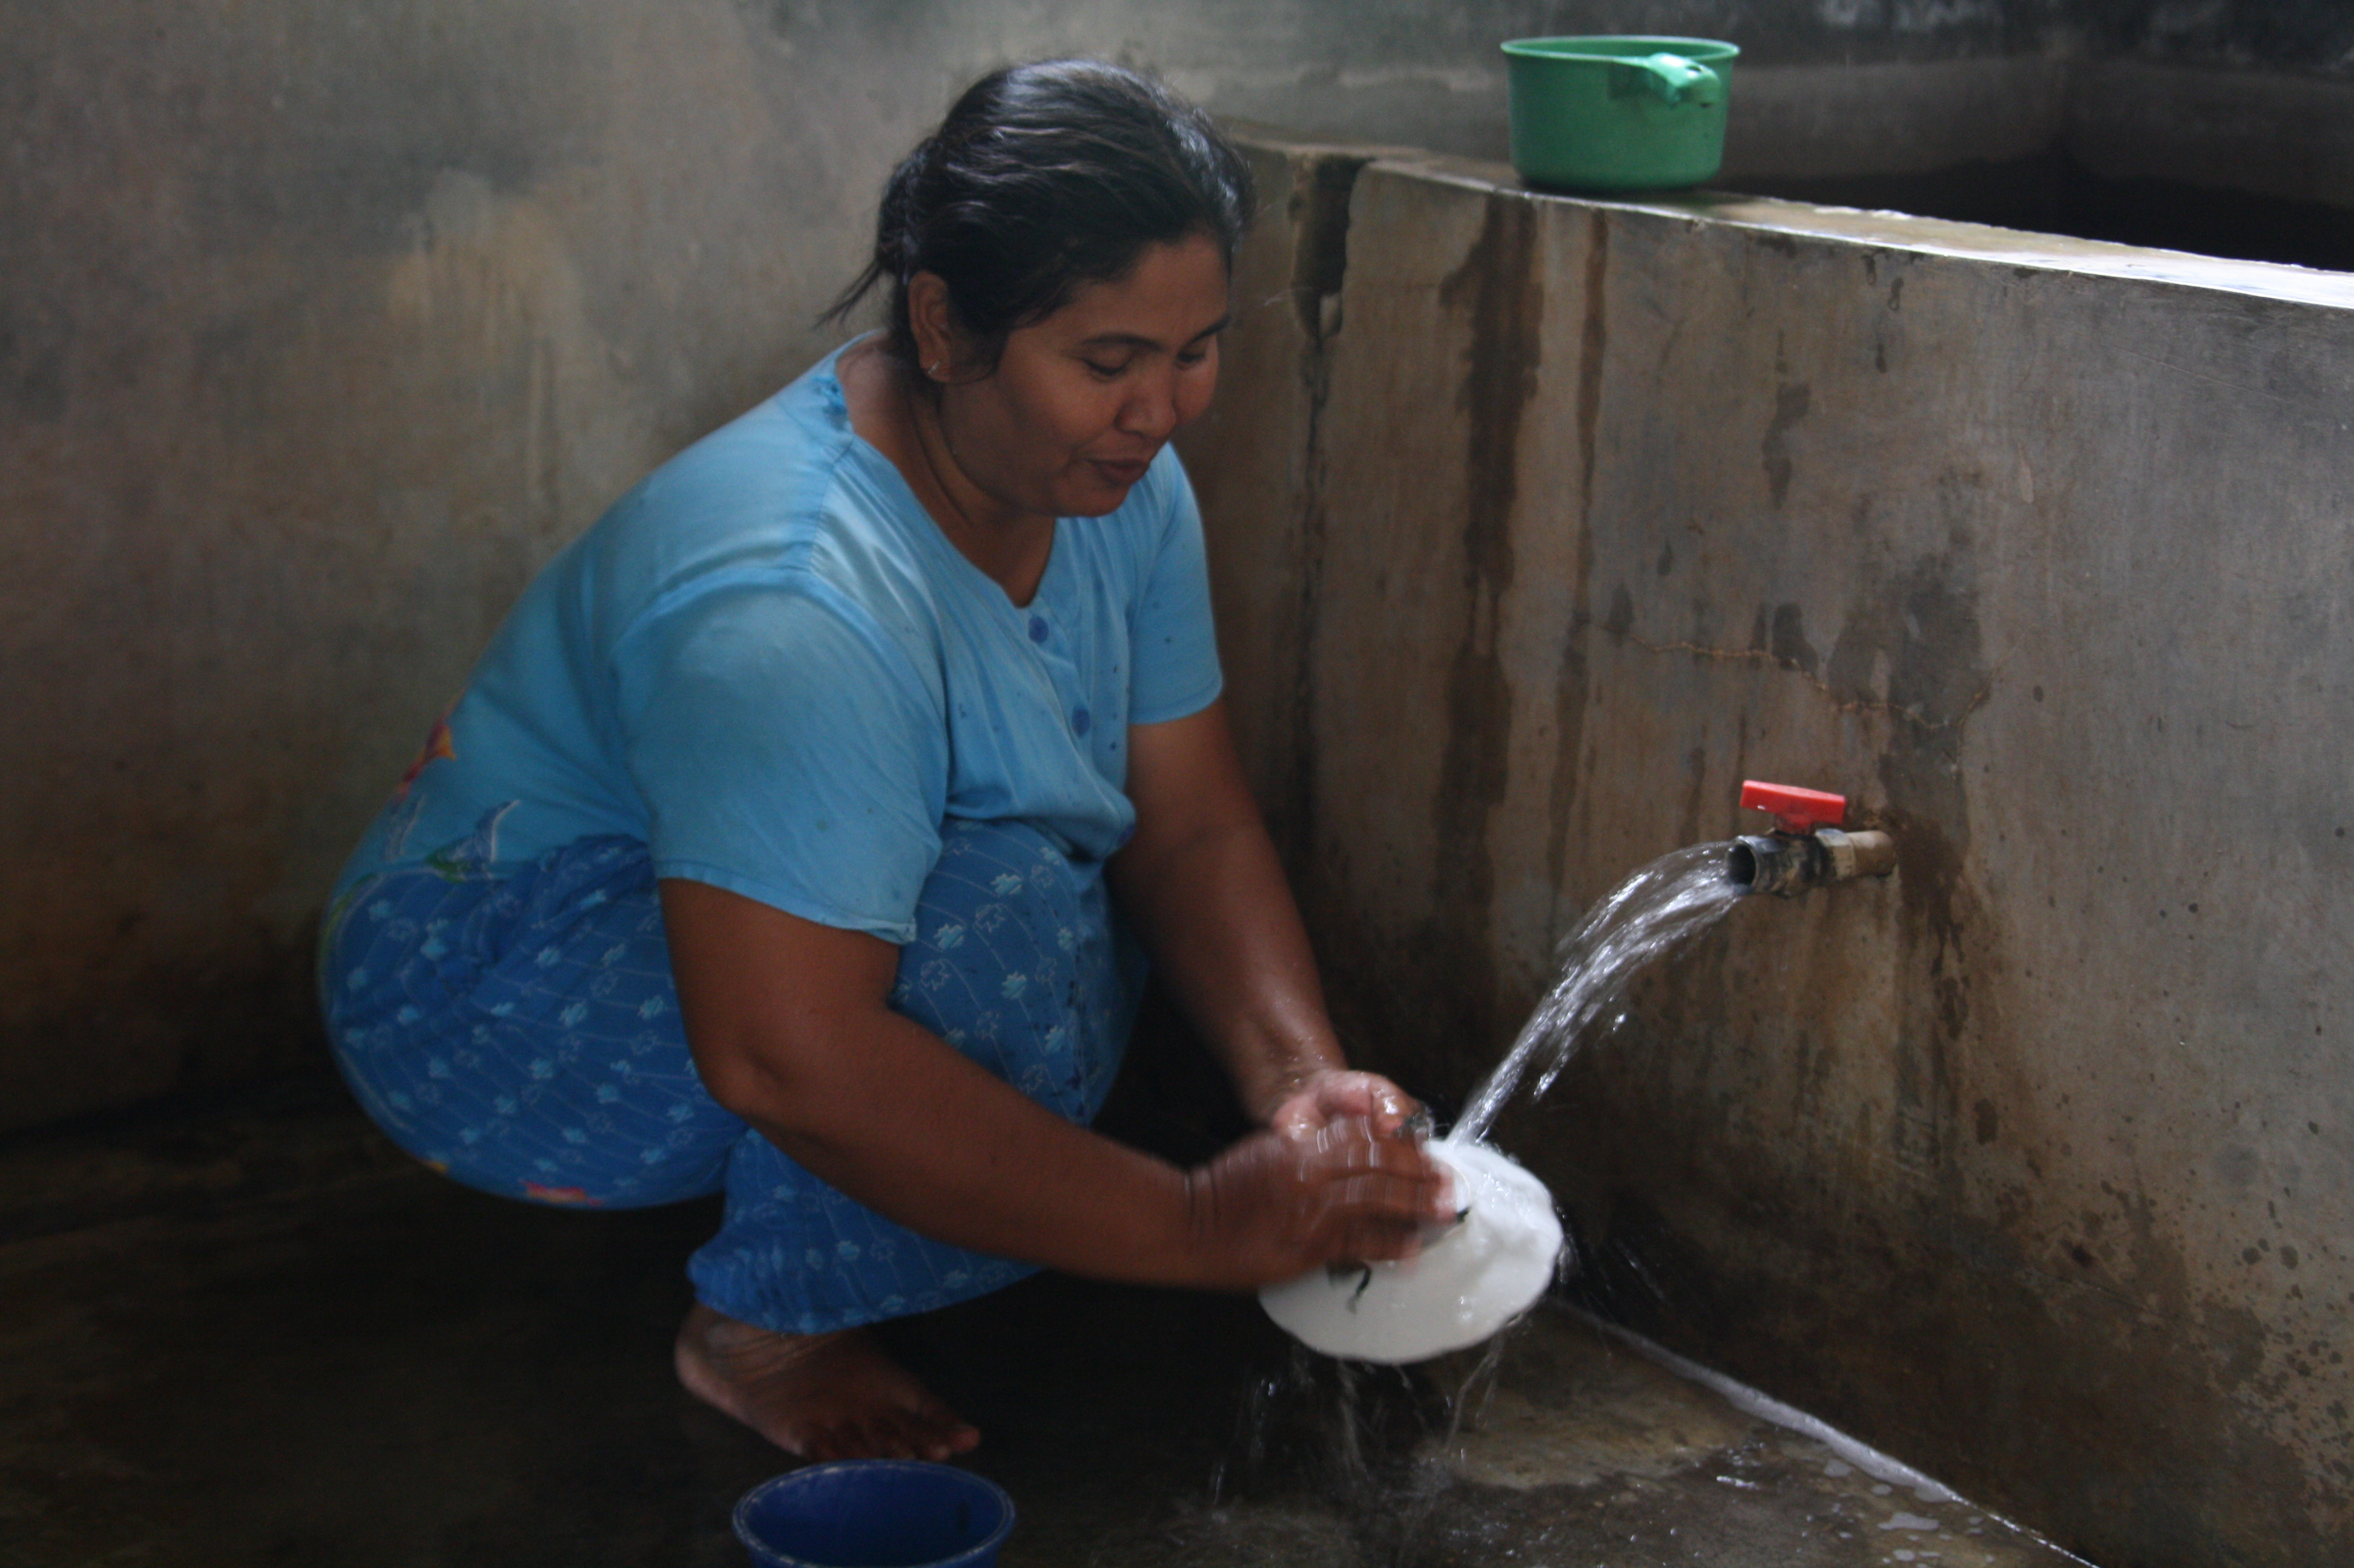

Clean Water in Aceh Barat © Indra Yogasara

*IMAGES OF THE STORY: Please share as attachment separately high resolution (above 1 MB) images to support the success story.*

|  |
| --- |
|  |

**THE OUTCOMES**

1. Local community organization Mata Ie Alue Pochik played a significant role in setting up the water network system to the community houses, as well as in the maintenance and financial management of the system. The network was paid for by the community members, via installments.

2. Mata Ie Alue Pochik emphasised the role and contribution of women in the project, as they have the strongest interest in clean water. In the village, women have become the most vocal advocates, with strong persuasive energy, in the promotion of clean water use and other health issues.

**THE ACTIVITIES**

In response to the problem, the Indonesian Red Cross (PMI) and American Red Cross constructed a new water network system in the villages and entrusted the system to the national water network - which in turn entrusted the system to the community.

The community revived the Mata le Alue Pochik – a local community organization involving 8 villages spread along 15 kilometers from Ladong to Lamreh – to be in charge of managing water distribution along the eight villages.

PMI conducted some training for additional capacity development, such as administration management, finance, and health promotion and brought the once defunct organization back to life.

**WAY FORWARD**

In addition to empowering and enhancing the role of women in the community, the program was successful in bringing about a great sense of shared ownership of the established water management system.

It was understood that strong community ownership would ensure the program’s continuity, just as the flow of water ensures the continuity of life.

Source: Hand in Hand - A Collection of Disaster Risk Reduction Success Stories, PMI, 2012, pg.64-65

IMPLEMENTING AND PARTNER AGENCIES LOGOS:

