**When First Aid Training Becomes Personal – singapore red cross**

***Singapore Red Cross -* Sondra Foo <sondra.foo@redcross.sg>**

*“I’ve learnt how first aid can save lives and it’s important to be prepared. You’ve got nothing to lose but everything to gain by learning first aid. You may be saving someone’s life one day.” Zainudin (Din) Ismail, a volunteer turned staff member of Singapore Red Cross Society (SRC), who by his first aid skills saved the life of a friend.*

*IMAGES OF THE STORY: Please share as attachment separately high resolution  
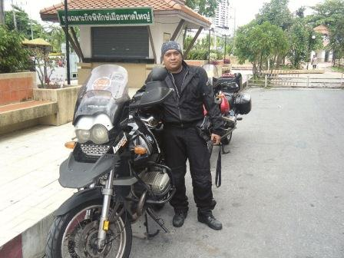*

© Singapore Red Cross

**THE PROBLEM:** *(Please specify the geographical location, issues and background to the project)*

One day, a group of Singaporean bikers set off on an exciting road trip to Malaysia, Thailand and Laos.

Six days into the trip, in the Laotian province of Thakek, disaster struck. One of the riders suddenly lost control of his bike and crashed.

The accident occurred in a remote area – there were no houses or villages, and no passing vehicles to flag down. They were on their own.

**THE ACTIVITIES**

One of the injured riders from the accident, Yani, had a bone protruding with blood trickling from her right upper arm. Her left boot was nowhere in sight and her left ankle was dislocated.

Luckily, one of the members, Zainudin (Din) Ismail was trained in First Aid.

Din says he knew he had to remain calm and act fast. “I quickly started administering first aid by using saline and cotton wool to clean the wound on her ankle. To try and stop the bleeding, I used some gauze with a crepe bandage to wrap around it. The fracture needed immobilizing but I didn’t have a splint so I took one of the pannier bars from the motorcycle and placed it beside the fracture and used bandages to secure it. I then turned my attention to the fracture on Yani’s arm. Her riding jacket was too thick for my scissors to cut, so I secured another pannier bar to her right upper arm with bandages. By then, help finally arrived. One of my friends managed to stop a passing truck. With Yani’s arm and leg firmly secured, we slowly lifted her onto the truck.”

The group made their way to hospital and Yani was evacuated the following morning to Bangkok for surgery. Only at the hospital did they realise that Yani had a punctured lung and ruptured spleen and her condition was life threatening. It became clear that Din’s first aid probably saved her life for the critical surgeries ahead.

*IMAGES OF THE STORY: Please share as attachment separately high resolution (above 1 MB) images to support the success story.*

|  |
| --- |
| **THE OUTCOMES**  Yani's road to recovery was smooth, and said that her family and friends made her healing journey easier. She and her husband are very thankful to Din and the others who were with them at the time of the incident. She said, “It will be great if everyone has basic first aid knowledge as no one would panic then.” |

IMPLEMENTI NG AND PARTNER AGENCIES LOGOS:

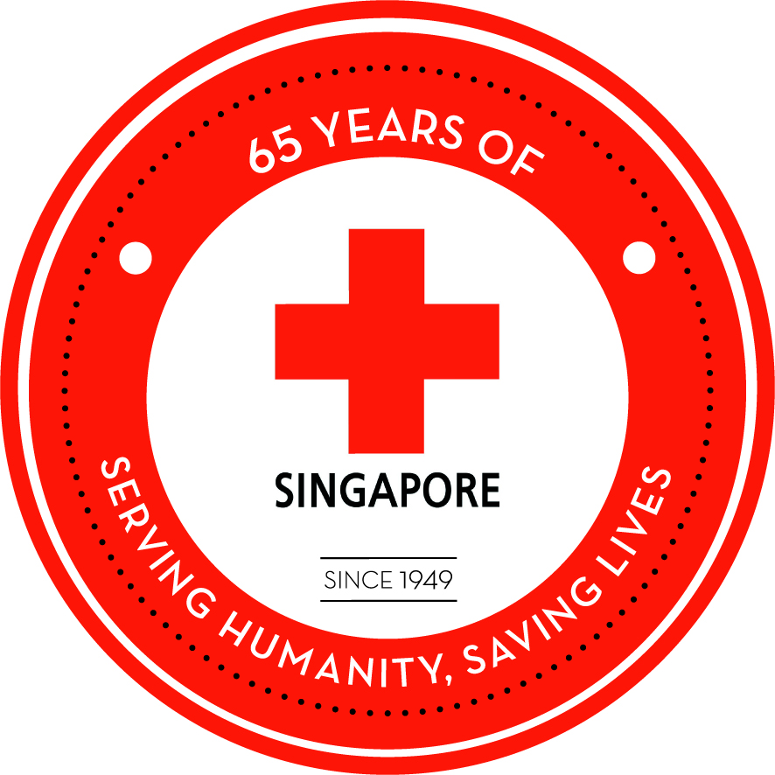

**WAY FORWARD**

Recognizing that the first aid duties are the way of protecting the community, the Singapore Red Cross works with over 200 active First Aiders to provide more than 10,000 man hours of service every year, among whom the champion could commit up to some 200 hours of service per year .(http://www.redcross.org.sg/articles/community-first-aid)