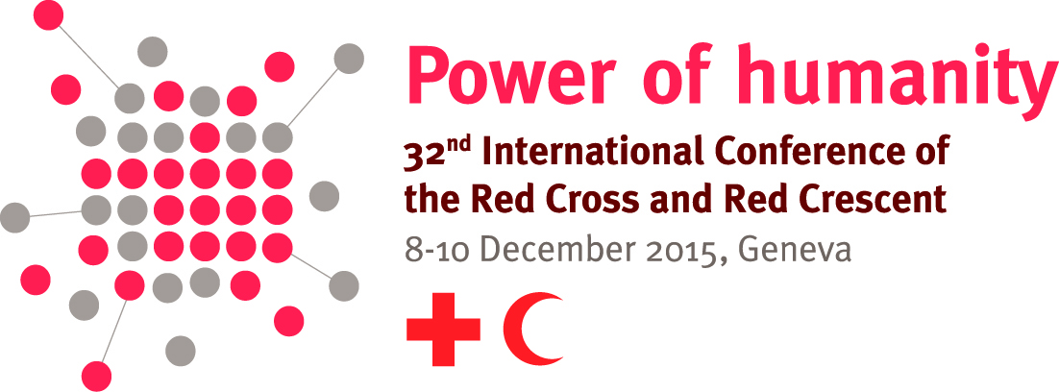

Model text for pledges related to strengthening legal frameworks for disaster response, risk reduction and first aid

This document sets out a menu of potential clauses that might be used in pledges related to strengthening legal frameworks for disaster response, risk reduction and first aid. It is not expected that every element suggested here will be included in every pledge. It is up to each National Society and government making a pledge to decide what makes best sense for their contexts.

It is recommended that National Societies and governments make joint rather than individual pledges on these issues, to reinforce their commitment to work together. This might either be on a bilateral basis or in another grouping (such as a regional group).

It should be recalled that the development of legislation, policies and rules is a time-consuming process. In some cases, it may well take longer than the four years separating International Conferences to finalize such a project. National Societies and states are nevertheless encouraged to make a pledge to undertake such projects where they find it appropriate, while also including some indicators and milestones that can be completed before the next International Conference.

Menu of potential pledge clauses

The Government[s] and National Society[ies] of [COUNTRY/REGION] jointly pledge:

General

- To cooperate in ensuring effective [development/implementation] of domestic laws and policies relevant to emergency and disaster risk management.
- To cooperate in strengthening regional solutions to regulatory problems in emergency and disaster risk management.
- To provide our support to other countries [in our region] that are interested in assessing and strengthening their laws on emergency and disaster risk management.

Accelerating progress in the facilitation and regulation of international disaster response

- To cooperate in developing, reviewing and strengthening our laws and procedures for managing international disaster response, drawing on the “Guidelines for the domestic facilitation and regulation of international disaster relief and initial recovery assistance” (IDRL Guidelines).
- To support [an inter-agency mechanism] at national level to regularly plan for the facilitation and regulation of international disaster response.
- To cooperate in disseminating information about the most valuable contributions in the event of major disasters and to discourage unnecessary or inappropriate in-kind donations
- To cooperate regionally in sharing information about our laws and procedures related to international disaster response
- To foster dialogue about further strengthening regional and global normative frameworks for the facilitation and regulation of international disaster response.
Strengthening laws for disaster risk reduction

- To cooperate in using the “Checklist on law and disaster risk reduction” to assess our legal framework for disaster risk reduction.
- To cooperate in raising public awareness about the rights and responsibilities of individuals, government and others under the law when it comes to disaster risk reduction.
- To cooperate in the [development/implementation] of provisions of [law/policy] empowering communities and vulnerable people to participate in decision-making about disaster risk management activities.

Providing supportive legal frameworks for saving lives through first aid

- To cooperate in reviewing [and strengthening] our laws and procedures for the promotion of first aid training and provision.
- To cooperate in promoting widespread first-aid training of appropriate quality.
- To cooperate in identifying steps to reduce potential concerns of citizens about liability or legal complications related to providing first aid

Menu of potential indicators and milestones

- Research reports and shared recommendations drafted on existing law related to disaster risk management and/or their level of implementation
- Workshops/interviews/surveys to discuss the effectiveness of existing laws related to disaster risk management completed
- Workshops held with relevant stakeholders to use the “Checklist on law and disaster risk reduction”
- New legislation/regulations/policies/rules drafted
- New legislation/regulations/policies/rules adopted
- Terms of reference agreed for an inter-agency mechanism for planning the facilitation and regulation of international disaster assistance. Mechanism meets at least annually to discuss relevant issues.
- Regional compendium of relevant laws drafted with participation of relevant stakeholders.
- Public information materials and information shared on rights and responsibilities related to disaster risk
- Regional meetings to discuss potential tools to resolve regulatory problems in disasters hosted
- Projects completed in # other countries with our technical advice or other support.
- Workshops hosted concerning further strengthening regional and global normative frameworks for the facilitation and regulation of international disaster response

For more information, please contact lucia.cipullo@ifrc.org

