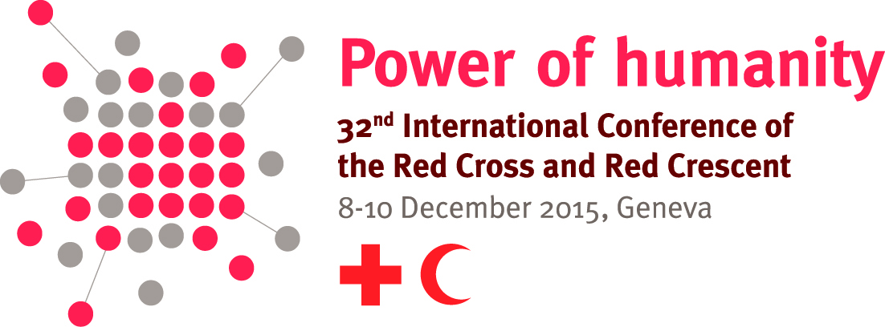

Model text for
Southeast Asia National Societies joint regional pledge on
strengthening legal frameworks for disaster response, risk reduction and first aid (‘disaster law pledge’).

For the years 2016 – 2020, the National Societies of Southeast Asia jointly pledge:

General

- To cooperate, collaborate, and strengthen the role of the Red Cross Red Crescent in ensuring the effective development and implementation of domestic laws and policies relevant to emergency and disaster risk management.
- To support the strengthening of regional solutions to regulatory problems in emergency and disaster risk management.
- To provide advice and support to other countries, National Societies and key partners that are interested in assessing and strengthening laws on emergency and disaster risk management.
- To establish a regional disaster law advisory group or committee for Southeast Asia, to share experiences, information and foster collaboration.

Accelerating progress in the facilitation and regulation of international disaster response

- To cooperate and share experience and information about developing, reviewing and strengthening our laws and procedures for managing international disaster response, drawing on the “Guidelines for the domestic facilitation and regulation of international disaster relief and initial recovery assistance” (IDRL Guidelines).
- To foster dialogue about further strengthening regional and global normative frameworks for the facilitation and regulation of international disaster response.
Strengthening laws for disaster risk reduction

- To cooperate in using and promoting the “Checklist on law and disaster risk reduction” to assess legal frameworks for disaster risk reduction.
- To cooperate in the development and implementation of law and policy which empowers communities and vulnerable people to participate in decision-making about disaster risk management activities.

Providing supportive legal frameworks for saving lives through first aid

- To cooperate in reviewing and strengthening our laws and procedures for the promotion of first aid training and provision.
- To cooperate in promoting widespread first-aid training of appropriate quality at the national and regional levels.

