AYVP Cambodia Report

- Brief introduction
- The ASEAN with the funding support of the USAID, developed Youth Volunteer programme called “ASEAN Youth Volunteer Program (AYVP)” for the ASEAN Countries. The execution of this programme has been assigned to the University Kebangsaan Malaysia (The National University of Malaysia -UKM), who acts as the AYVP secretariat, leading its implementation.
- The AYVP aims to develop and support the ASEAN Youth volunteerism for innovative solutions to the social, cultural, economic and environmental challenges facing communities across ASEAN. The programme’s purpose is to send AYVP volunteers to carry out work in other ASEAN countries (Priority has been given to Cambodia, Philippines, and Myanmar). The AYVP secretariat is now in the process to develop its first country programme in Cambodia, developing some pilot tools, structure and principles that can provide direction and be replicated in different ASEAN countries with various partners. As mentioned above, Cambodia was selected for 2015, Philippines will be implemented in 2016 and Myanmar in 2017. Krakor floating village, Cambodia was selected as one target community for 2015 project.
- For this project, IFRC regional office and AYVP built a partnership and conducted one preparing meeting in Malaysia June 9-10 and concluded that the activities to be carried in June, July and August into three phases in Phnom penh and Krakor village, Cambodia
- Phase 1: programe planning (June 18-19, AYVP facilitators’ training and field visit)
- Phase 2: Identification and assessment (July 10-15, to Krakor village by the technical trainers of IFRC and AYVP).
- Phase 3: Programme Implementation (August 2-29, pls find annex 1; AYVP programme)
- Process and Outcomes
2.1 Phase 1: Programme planning
Process
- The AYVP secretariat and IFRC have organized a 2- day workshop in June 18-19 for 6 youth facilitators in Phnom-Penh,Cambodia to sensitize about the community work as well as to develop a plan of action.

- The IFRC has been offered to be co-facilitator for this workshop and the regional Youth and Volunteering officer together with the IFRC Cambodia Country Support Coordinator have conducted the workshop and carried the community visit in a connection with the Cambodia Red Cross Branch.

- In the workshop, agenda for volunteers role and responsibility followed by RC orientation, security and safety, and the code of conduct, anti-harassment and gender equality, child protection were addressed and a field visit to Krakor Floating Village (in the Pursat Province) for the sensitization and assessment was arranged for programme planning.

- In the Krakor village, there was a focused group discussion with the community leader with the support of the Krakor Sub-branch. The Krakor Floating Village (in the Pursat Province) is a floating village with majority nationals of Vietnamese migrants with Vietnamese Religion and affected by floods every year and every monsoon season. The most urgent priority is the area of water and sanitation. They rely on the river water for drinking and open defecation to same river water. No safe water and sanitation facilities are available. Hygiene promotion has not been done. RC two volunteers are available and their role is to communicate with the Krakor branch when disaster happens. Until now there has been no regular visit and regular support from the Krakor Branch. However there established a good relationship between commune leader and sub branch.

Outcomes
- 7 key action plans were developed for August programme through consultation and discussion between IFRC and AYVP.
No | Action plan
0 | Opening and Closing Ceremony with Khmer Dance
1 | Theoretical session; Sensitization about Volunteerism and Introduction of WASH
2 | Field session; Basic Field Assessment in Krakor
3 | Water quality test and ceramic water filter distribution/ installation/ usage/ maintenance
4 | Hygiene promotion
5 | ASEAN identity and WASH Awareness campaign(music, dance, sports, visual-arts, Theatre)
6 | ASEAN Youth Empowerment Forum
7 | Programme Management Planning for ASEAN youths

- IFRC and AYVP agreed to have a real field assessment by the technical team for the further confirmation and mapping in July

2.2 Phase 2: Identification and assessment
Process
- IFRC Southeast Asia Regional WatSan delegate and AYVP programme people visited to Krakor village and identified locations for water filters(action No 3) and made assessment how to implement the community actions for ASEAN Youths delegates from July 10-15.

(Pls find an annex 2; Technical report of WatSan delegate)
Outcomes

Technical group recommended as follows after the assessment in Krakor village.
- Water
All protected water sources that are introduced to a community should include the formation and training of a water point committee to ensure that there are community members to repair the pump, collect money to purchase spare parts and ensure hygiene around the well

In areas where there are insufficient protected water sources, the treatment of drinking water should be taught. Either boiling or filtering and treating with chlorine bleach should be an integrated part of the water point committees training program

Link should be developed with community and Communue to determine the reliability of water point/sources, their proper maintenance and protection, the effectiveness of the water committees maintenance and protection of water sources.

Additionally, the regular cleaning of water storage containers and promotion of a lid to minimize opportunities to contaminate drinking water should be part of a water hygiene program

- Sanitation/Latrines
When mounting a latrine promotion campaign, the safety, security and hygiene of excreta disposal methods should be emphasized. The former to encourage households teach their young one use the latrines. However, the construction of any type of latrine should be encouraged. If people do prefer a traditional design, govt. staff should offer maximum help to ensure that the latrine is safe and can be maintained properly.

In cases where people do not have latrine because of lack of tools or there is no on to dig it, means to eliminate these excuses should be offered.

Sanitation education should include messages about excreta disposal when away from home. As the majority of the rural population is pastoralists they spend long periods of time away from the house. In addition, use of lake for defecation and urination should be strongly discouraged, especially because many people obtain their drinking water from this source.

Households should be trained to properly locate latrines so that at the end when and if people continue to construct latrines, they will not risk contamination of water sources.

- Hygiene

Many people reported washing their hands before eating or after eating and before prayers. Relatively few, however, reported washing hands after “using the latrine” it is recommended that education should proceed to increases community awareness.

Additionally, proper rubbish disposal should be encouraged as part of hygiene education campaign. For example, disposing waste/ grey water on the street surface or empty space outside the premises, avoiding leaving empty tins, bottles and broken utensils or glasses around the compound or the house where mosquitoes can bread and metal and glasses that can cut children should be part of the campaign.

- General for Capacity building and awareness creation

Water and sanitation activities should be fully integrated so that people understand links between unprotected water sources, diarrheal diseases (as well as other water related diseases such as bilharzia), latrine use and interruption of the fecal-route of disease transmission, and importance of hand-washing.
Health education should be done on all of the topics included in this survey, with particular emphasis on areas where knowledge was weak. In cases where misconceptions appeared to be fairly general across the population, they should be addressed though health education in target population.

Any intervention on water and sanitation should encourage ownership, self-reliance and self-help. An attitude of “CARE MUST DO FOR US” was frequently encountered during the quantitative and qualitative study (especially when enumerators asked the respondents if they had “any other comment’. There is need to emphasize community’s ownership of particular water points or latrines to promote ownership.

  - Phase 3: Programme Implementation
Process
- AYVP with the support of IFRC developed a module of AYVP Cambodia for community engagement based on recommendation from the technical visit.
- 47 Youths selected, from ASEAN Countries such as Brunei, Cambodia, Indonesia, Lao, Malaysia, Myanmar, Philippines, Singapore, Thailand and Vietnam through interview and strict criteria by AYVP have joined the final programme and designed to engage the ASEAN Youths to community activities with the theme of WASH in 2015 for Cambodia.
- All qualified trainers presenters were selected from the IFRC and deployed in the set timeframe according to programme and all logistics parts were supported by IFRC Cambodia office and Cambodia Red Cross.
- In the opening ceremony, Anne E LECLERC Head of IFRC SEA delegation made a presentation “Call for Youth action” with her inspiring speech.
- The programme has been divided into two categories; Theoretical sessions and Field sessions. Most of sessions were conducted by the IFRC and CRC staffs as follows
No | Action plan | Resourced Presenters
1 | Opening ceremony: Call for Youth action | Anne E LECLERC, Head of IFRC SEA Delegation
2 | Theoretical session; Sensitization about Volunteerism | Naomi AKAMATSU, IFRC APZ
3 | Field session; Basic Field Assessment in Krakor and Introduction of WASH | Sambo and Vanchan, CRC with the support of Narendra
4 | Water quality test and ceramic water filter distribution/ installation/ usage/ maintenance and ASEAN identity | AYVP Professor and Programme officer
5 | Hygiene promotion in Krakor families and schools | Narendra Singh, IFRC
6 | WASH Awareness campaign(music, dance, sports, visual-arts, Theatre) for Krakor | Kumju Ho, IFRC
7 | ASEAN Youth Empowerment Forum | Kumju Ho, IFRC
8 | Programme Management Planning for ASEAN youths | Suchada M, IFRC  LAK Mony Rasmey, IFRC Cambodia office
9 | Khmer Traditional Dance Training for closing ceremony | LAK Mony Rasmey, IFRC Cambodia office  Rou Sokhon, CRC

Outcome and Impact

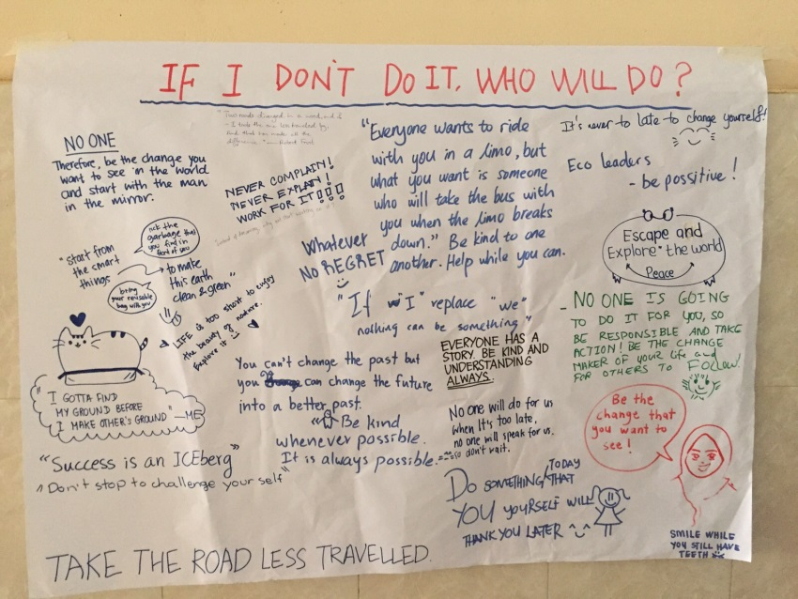
- 47 Youths were so motivated by theoretical sessions on the first days of programme and gained knowledge about volunteerism, community engagement and WASH
- In Krakor village, they installed Ceramic water filters in Community and conducted hygiene promotion in each individual houses and school. Altogether xx families/ household and xx children joined the hygiene promotion conducted by youths at houses and schools and gained knowledge about ceramic water filter and personal hygiene.
- In Youth empowerment forum, according to IFRC design and facilitation, all 47 youths proposed their specific individual issues and identified priority issues facing ASEAN youths and prioritized into 6 agenda as follows by extending one more half day for a discussion;
        - ASEAN Youth issues
        - Opportunities
        - Youth funding
        - Youth Leadership and commitment
        - Volunteer Safety and security
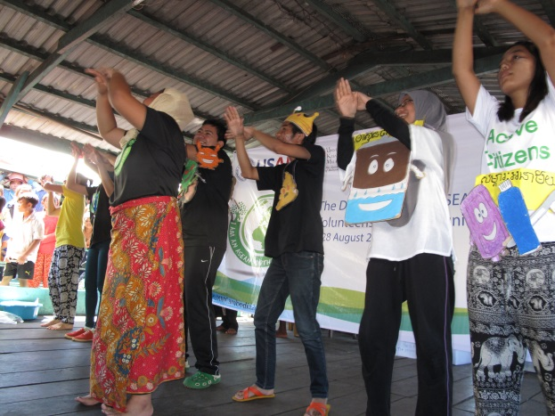
        - Measurable impact of the programme
- They debated and discussed real problems, root causes, and finally solutions how to change into a positive actions.(pls find annex 3; Outcome of youth forum)
- Impact of youth forum is that they committed fully by themselves to be agents of change for better and resilient society.
- Following the promotion, they prepared WASH awareness campaign divided by 5 groups – Music, Dance, Sports, Visual Arts, Theatre.
        - Music group theme; Clean water Use
        - Dance group theme; Hand washing
        - Visual arts theme: Water borne diseases and personal hygiene
        - Sport group theme: Clean environment and waste management
        - Theatre theme: Importance of Ceramic filter and Hygiene kit
- And they held a campaign in the community hall and around 300 community people gathered in the hall.
- They measured impact of the awareness raising campaign through questionnaire and 75% of community people gained knowledge about the WASH in a correct and clear way and changed attitude
- After the Krakor programme, all youths joined the programme management workshop and gained knowledge how to plan, monitor, evaluate and report with a good project proposal
- In closing ceremony, they danced a Khmer dance with full motivation and energy.
- Recommendation
This is the first time partnership with the AYVP and IFRC. It was an ad-hoc plan, however, overall, it went well and the programe was so effective in terms of youth empowerment and their development in community resilience action.
All ASEAN youth participants expressed their feelings, impressions and motivations about this programme and thanks to technical resource people involved in this programme, asked for more support to expansion such these programmes in any organizations. They realized youths play a most important role in DRR and community resilience.
Recommendations are as follows;
To expand more programmes for youths,
- Planning process should be begun earlier (at least 6 months earlier) before the next AYVP programme starts and before IFRC yearly planning process so that both parties can have clear roles and responsibility and allocate resources and times in advance for proper planning of programme. To do this, both parties should develop a partnership agreement and develop a budget, resources together.
- Technical personnel should be selected according to plan and be prepared in advance for deployment and get briefed by IFRC SEA office and AYVP.

