6.Diarrhoea treatment for adult and child
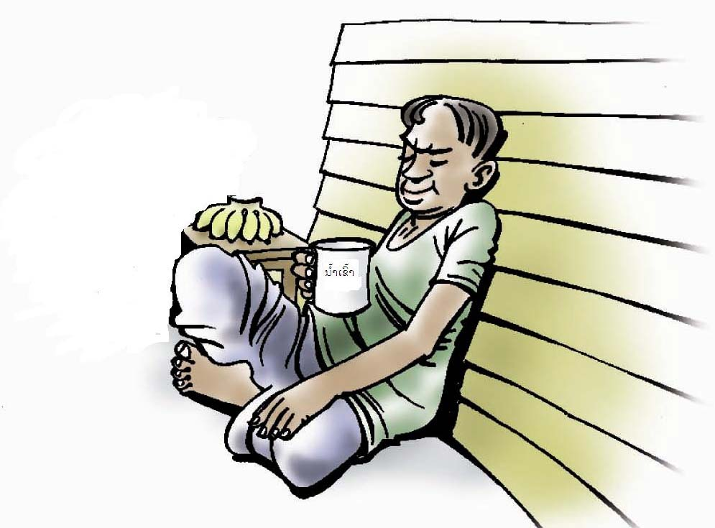

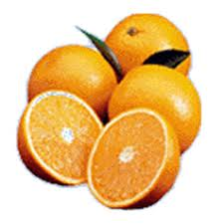
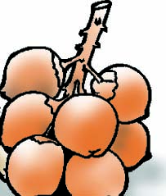

1.
- continue to give food based fluids to replace water and salt, e.g: rice soup, banana, coconut water
- drink more than usual every time after defecated
- give medication or traditional medicine to stop diarrhoea

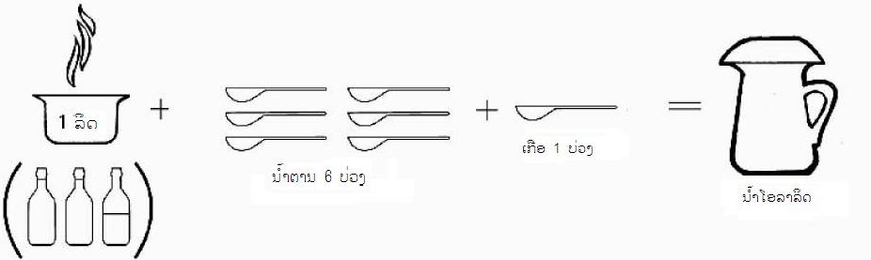
A. If ORS is not available, how to mix ORS?

 ​use clean pot to mix water, salt and sugar
B. If ORS is available
- mix the content of 1 ORS package into 1 liter of boiled water (equal 5 glasses of water)
- mix the content of 1 small ORS package in to 1 glass of boiled water (250 ml)
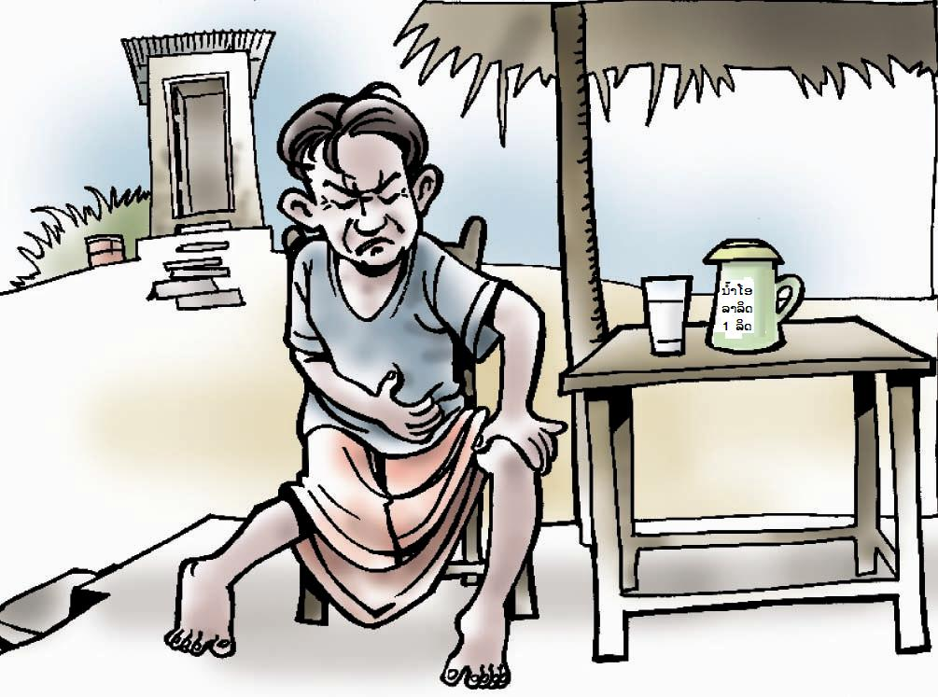

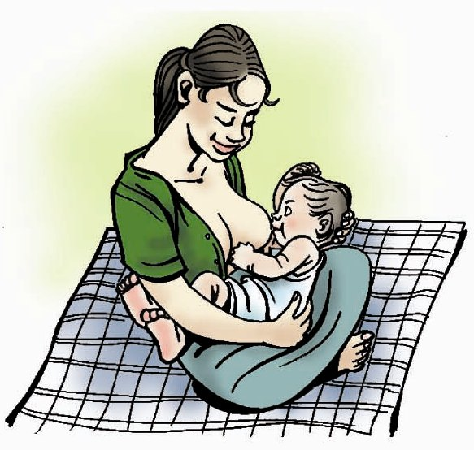

2.
Attention: If infants suffer from diarrhoea, continue and increase breast feeding
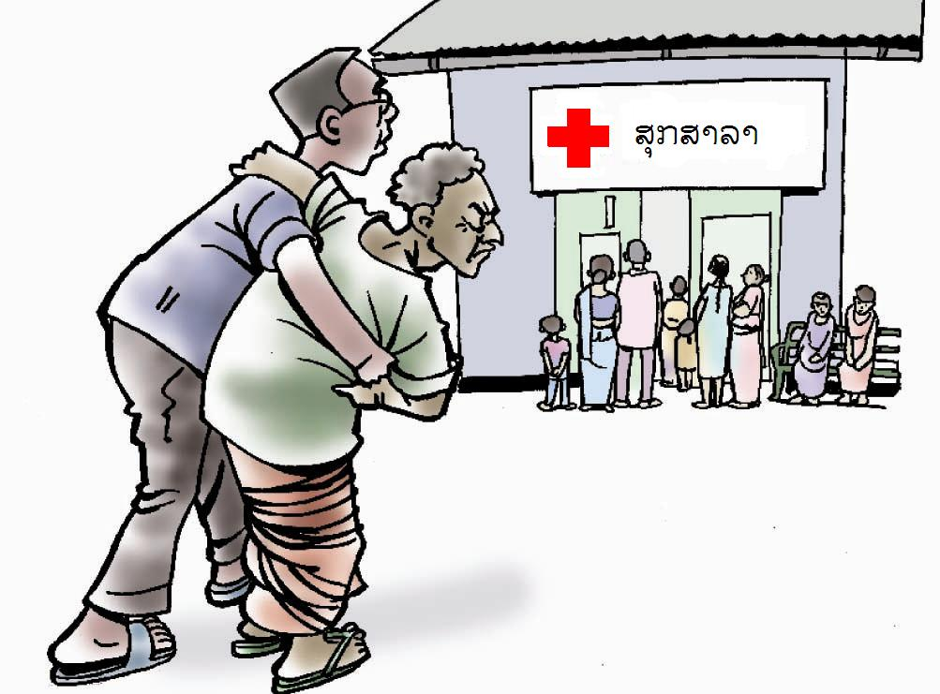

3.
If diarrhea does continue go to the health centre for help (see sign of diarrhea and dehydration)

