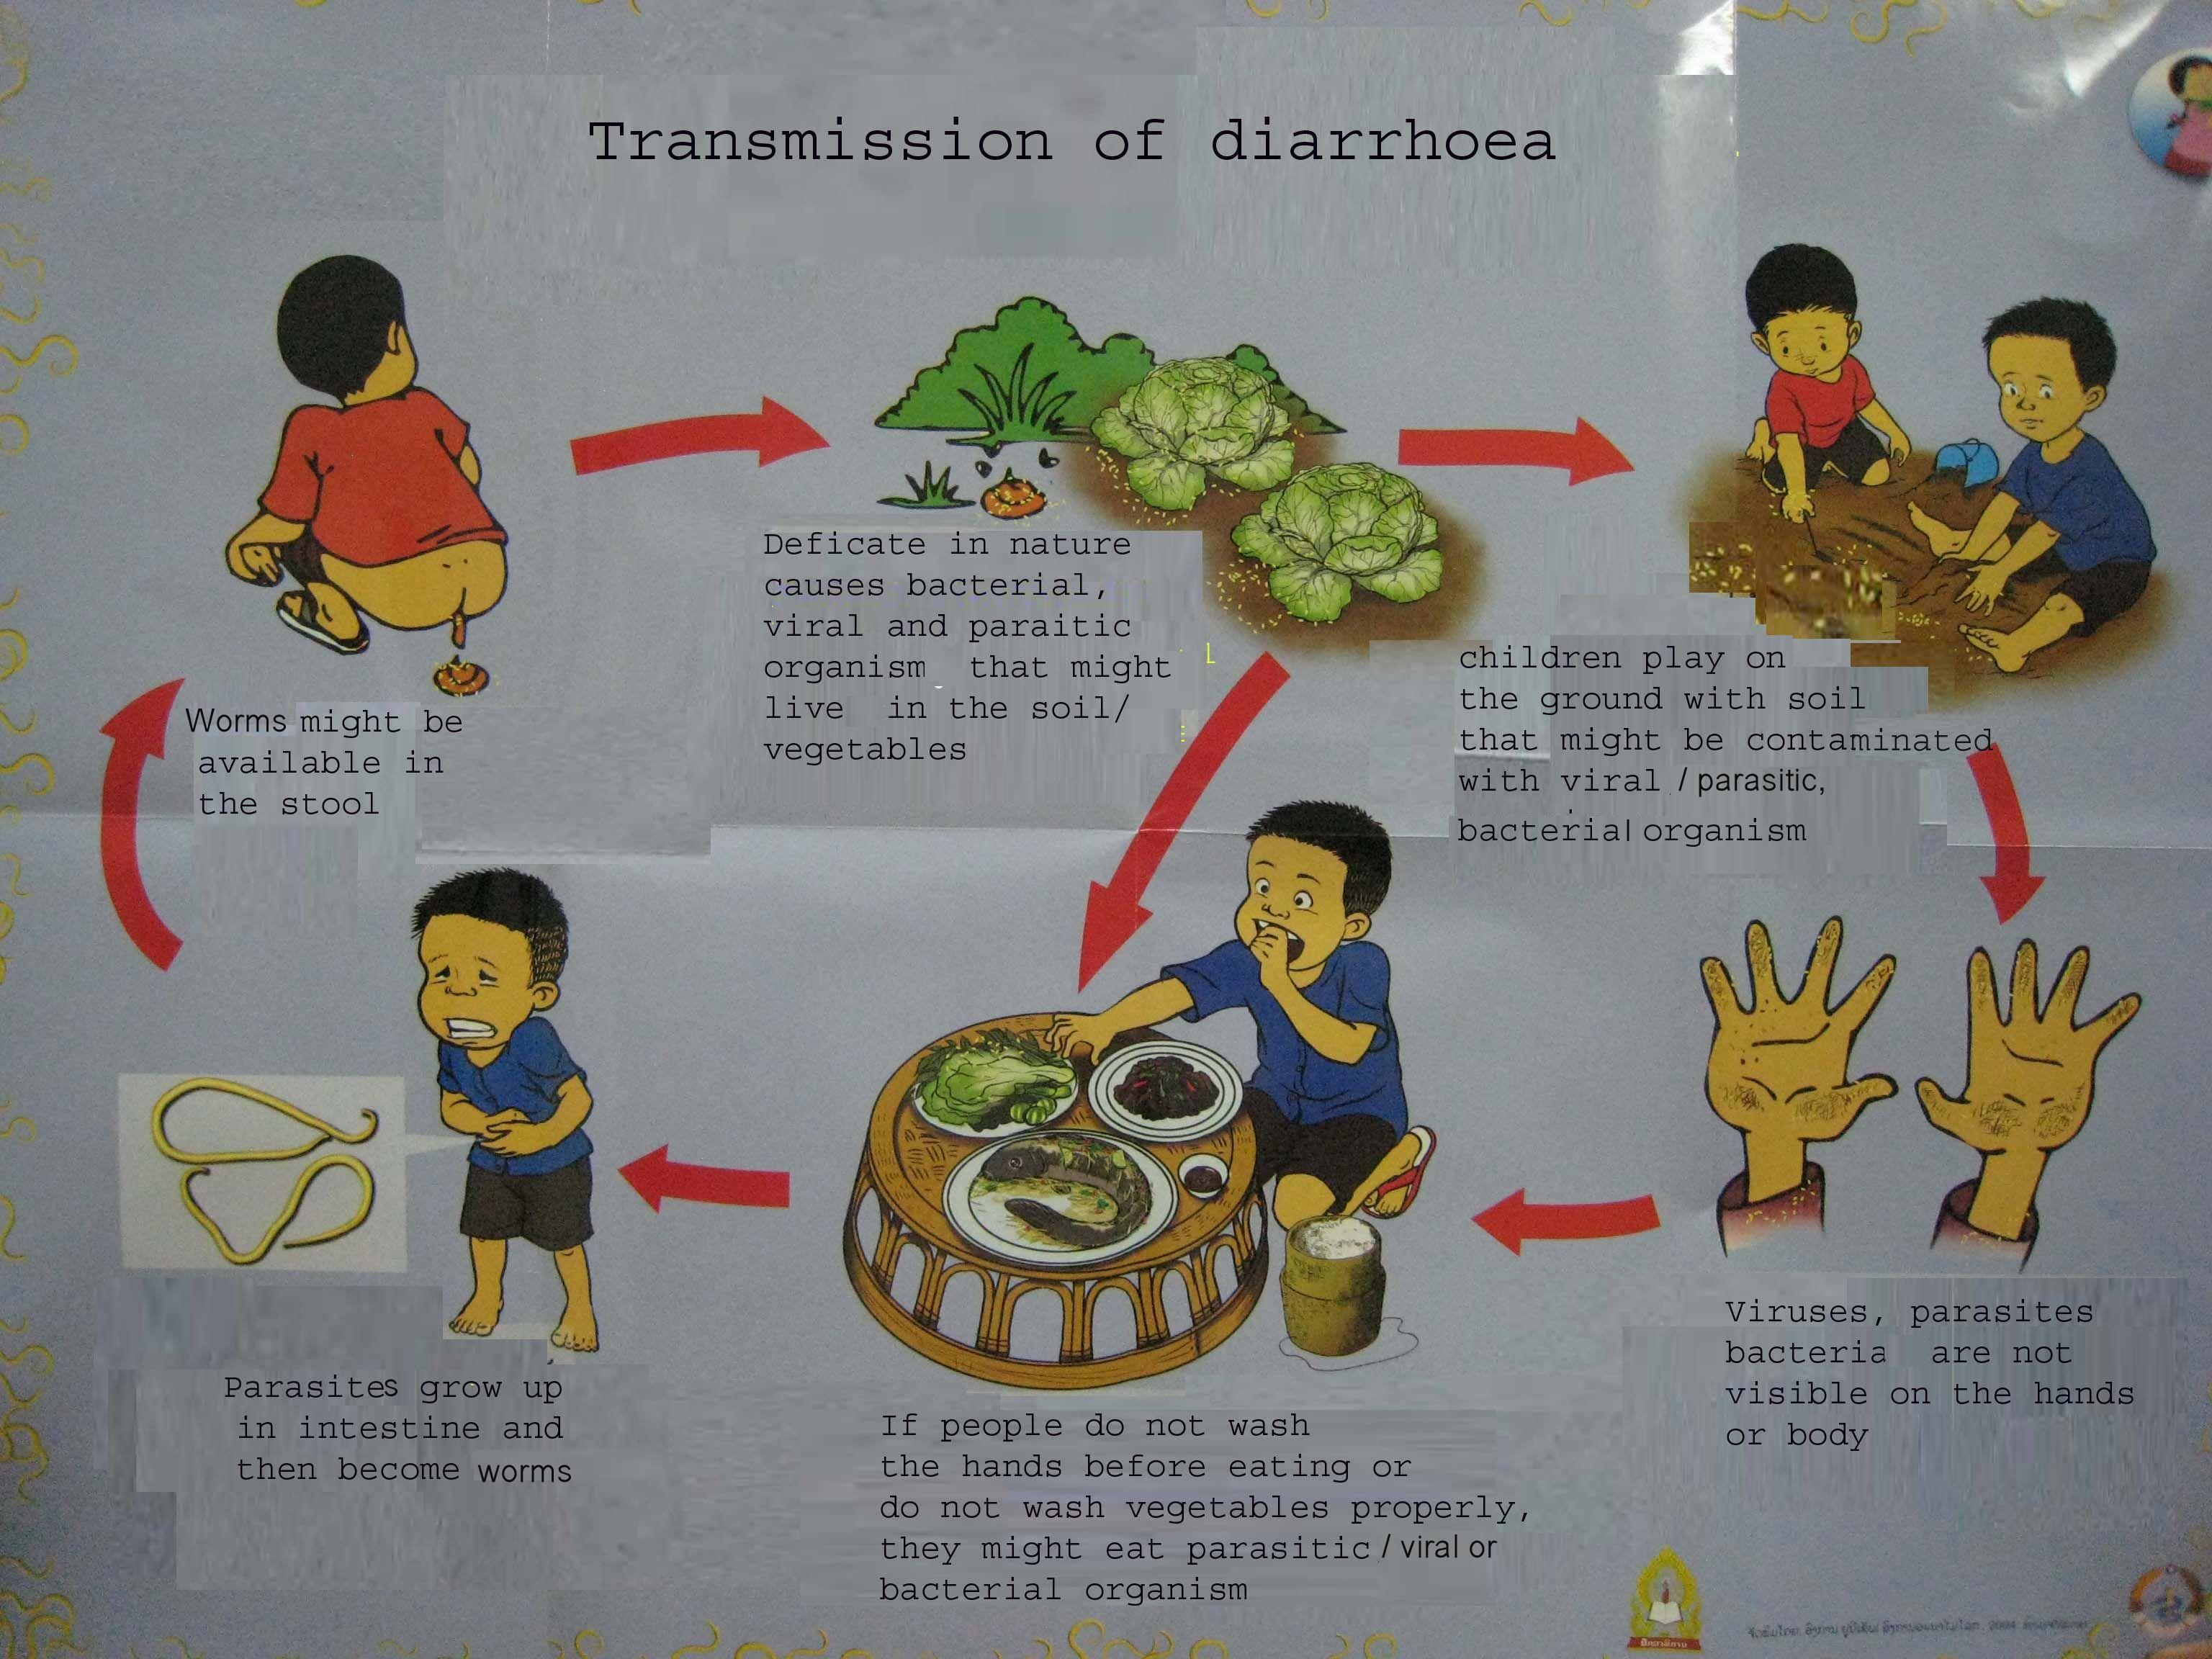
5. Transmission of Diarrhoea

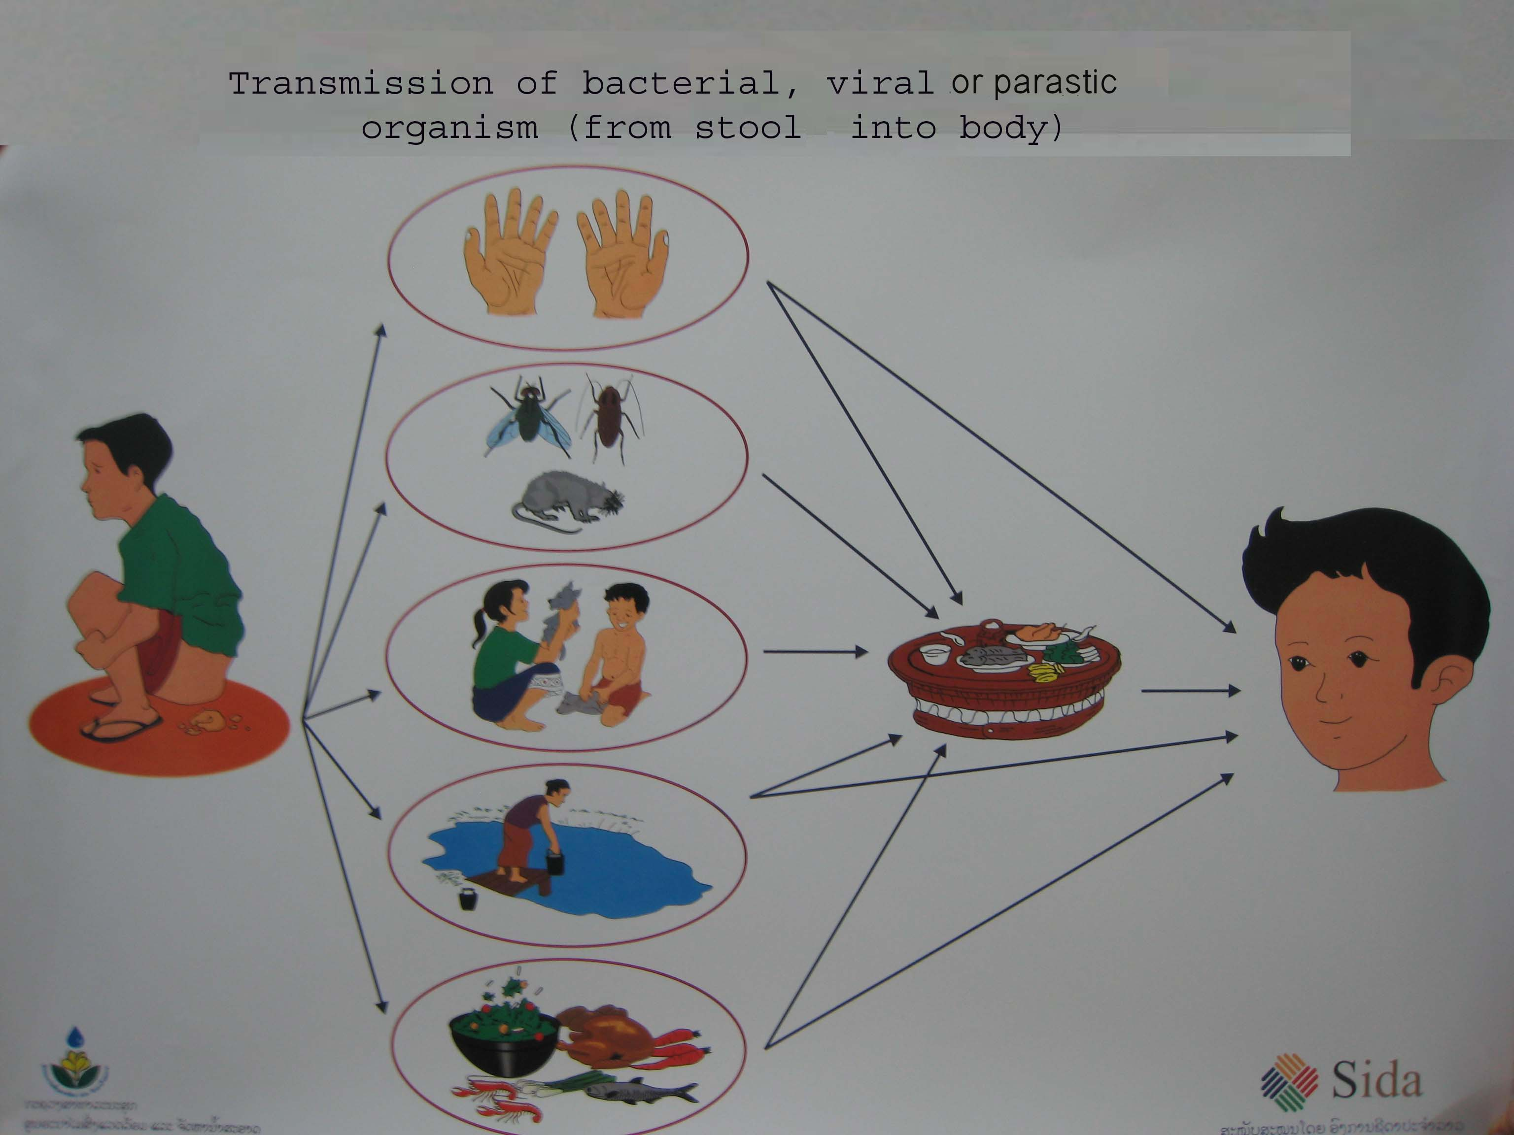

Transmission of diarrhoea
​Two main ways:
- Direct:
- Someone eats stool unconscious
- Dry stool is blown into the mouth
- Animals or flies contact stool and then contact human being’s mouth directly

- Indirect:
- Hands: When someone defecates in the nature or uses latrine but does not wash the hands properly, then bacterial, viral and parasitic organisms might get into/under the nails, hand lines, fingers. After that human being touch the food for eating and then bacterial, viral and parasitic organisms get into the mouth.
- Flies: ​ ​When someone defecates in the nature, flies might have contact with faeces and afterwards they might touch uncovered food.
- Soil: ​Usually children play on the ground and then they don’t wash the hands before eating. All bacterial, viral and parasitic organisms might get into the mouth.
- Water: People defecate in the nature might cause that the rain water flow stools into the river or well. After that people use un-boiled water for drinking, washing vegetables or utensils. This might cause bringing parasites into the mouth.
- Food: When people defecate on the grasses, animals might eat the grasses with parasites/bacteria/viruses. After that people eat uncooked or medium meat, it might bring parasites/germs/bacteria’s inside the body.
- Vegetables: ​Almost all families grow vegetable by themselves or for economical reasons. Sometimes they use animal faeces for growing vegetables. After that people eat un-washed or not properly washed vegetables. Bacterial, viral and parasitic organisms might get inside the body.
- Other utensils: If you do not clean up eating utensils properly then flies, cockroach or other animals might contact it. After people use the eating utensils again, bacterial, viral or parasitic organisms might get inside the body.

