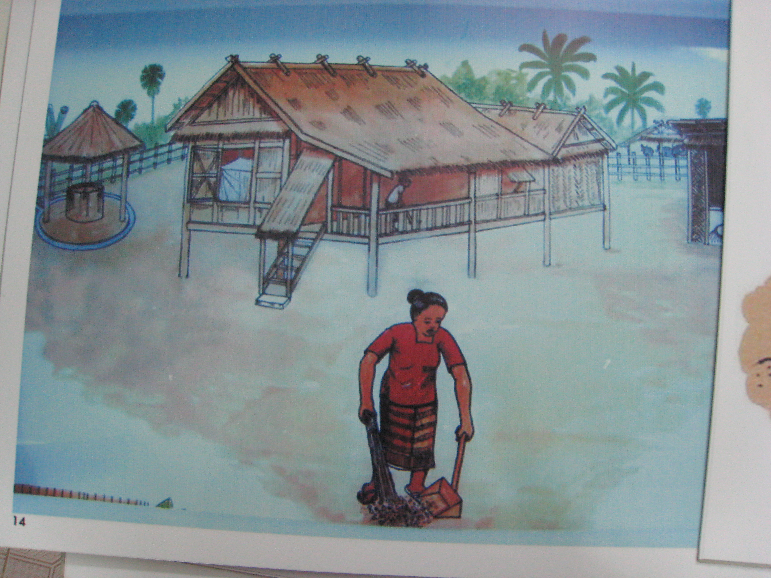
4. Environmental domestic hygiene

good behaviour:
- keep surroundings clean (no faeces in the house, yard, public places) and free from stagnant water
- clean inside the house and kitchen daily
- make the dishes and clean all eating utensils with water and liquid soap/ ash, dry it and store it safe
- ​​tidy up the house daily

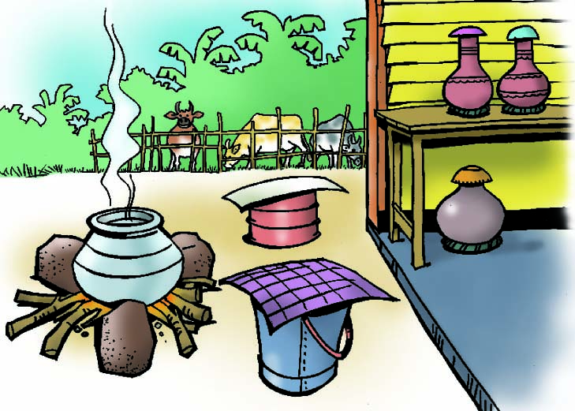

- keep water container and jar clean
- cover water container properly to protect it from dust and waste
- ​don’t keep domestic animals free inside and around the house (it needs fences and doors around the yard and doors on the houses)

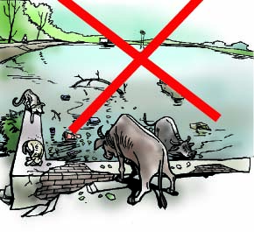

- protect drinking and other water sources from animals
- keep water sources clean, do not throw waste into the river
- do not let animals bath in the pond or river

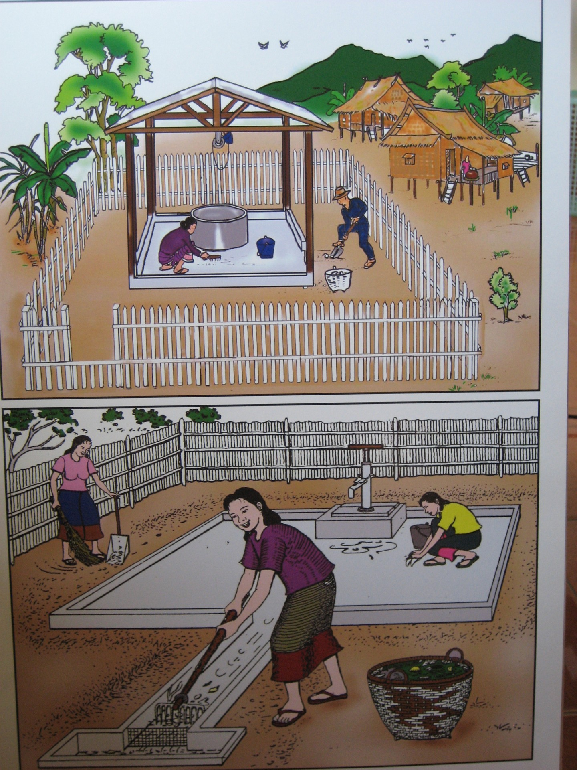

                - cover and protect well, pump
                - make the drainage
                - do not throw waste into the drainage channels
                - make fences + doors around the well, water tank and tap stand
                - put the bin inside the fence ​

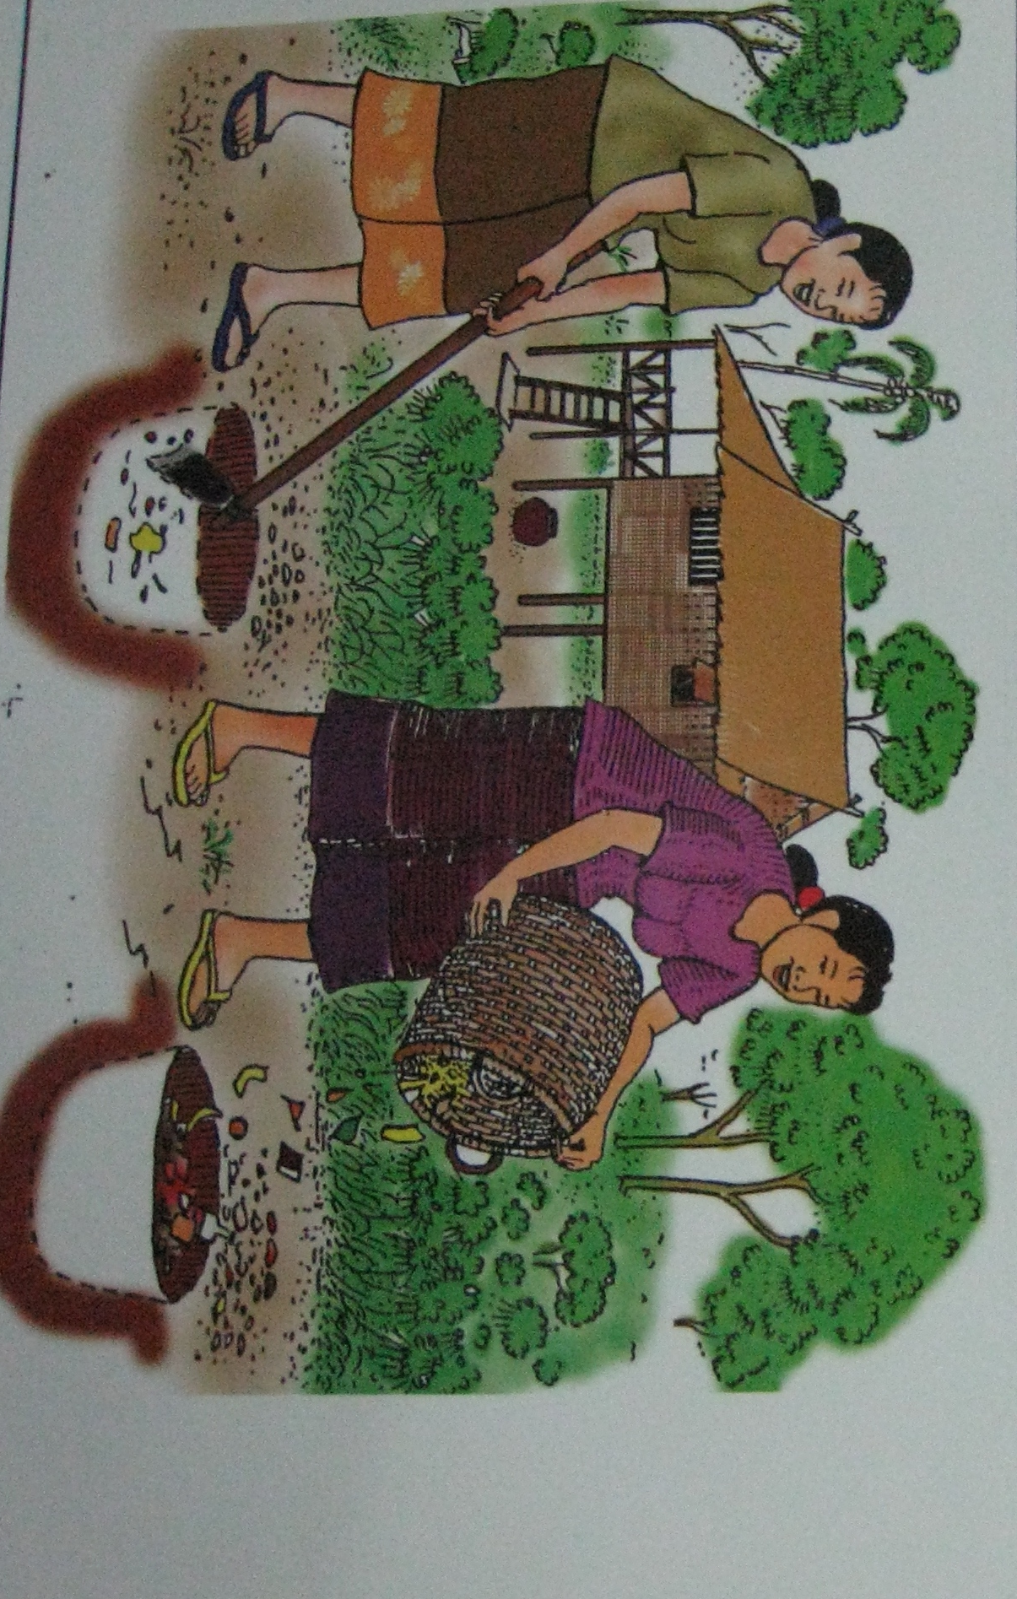
- dispose waste by burning or burring

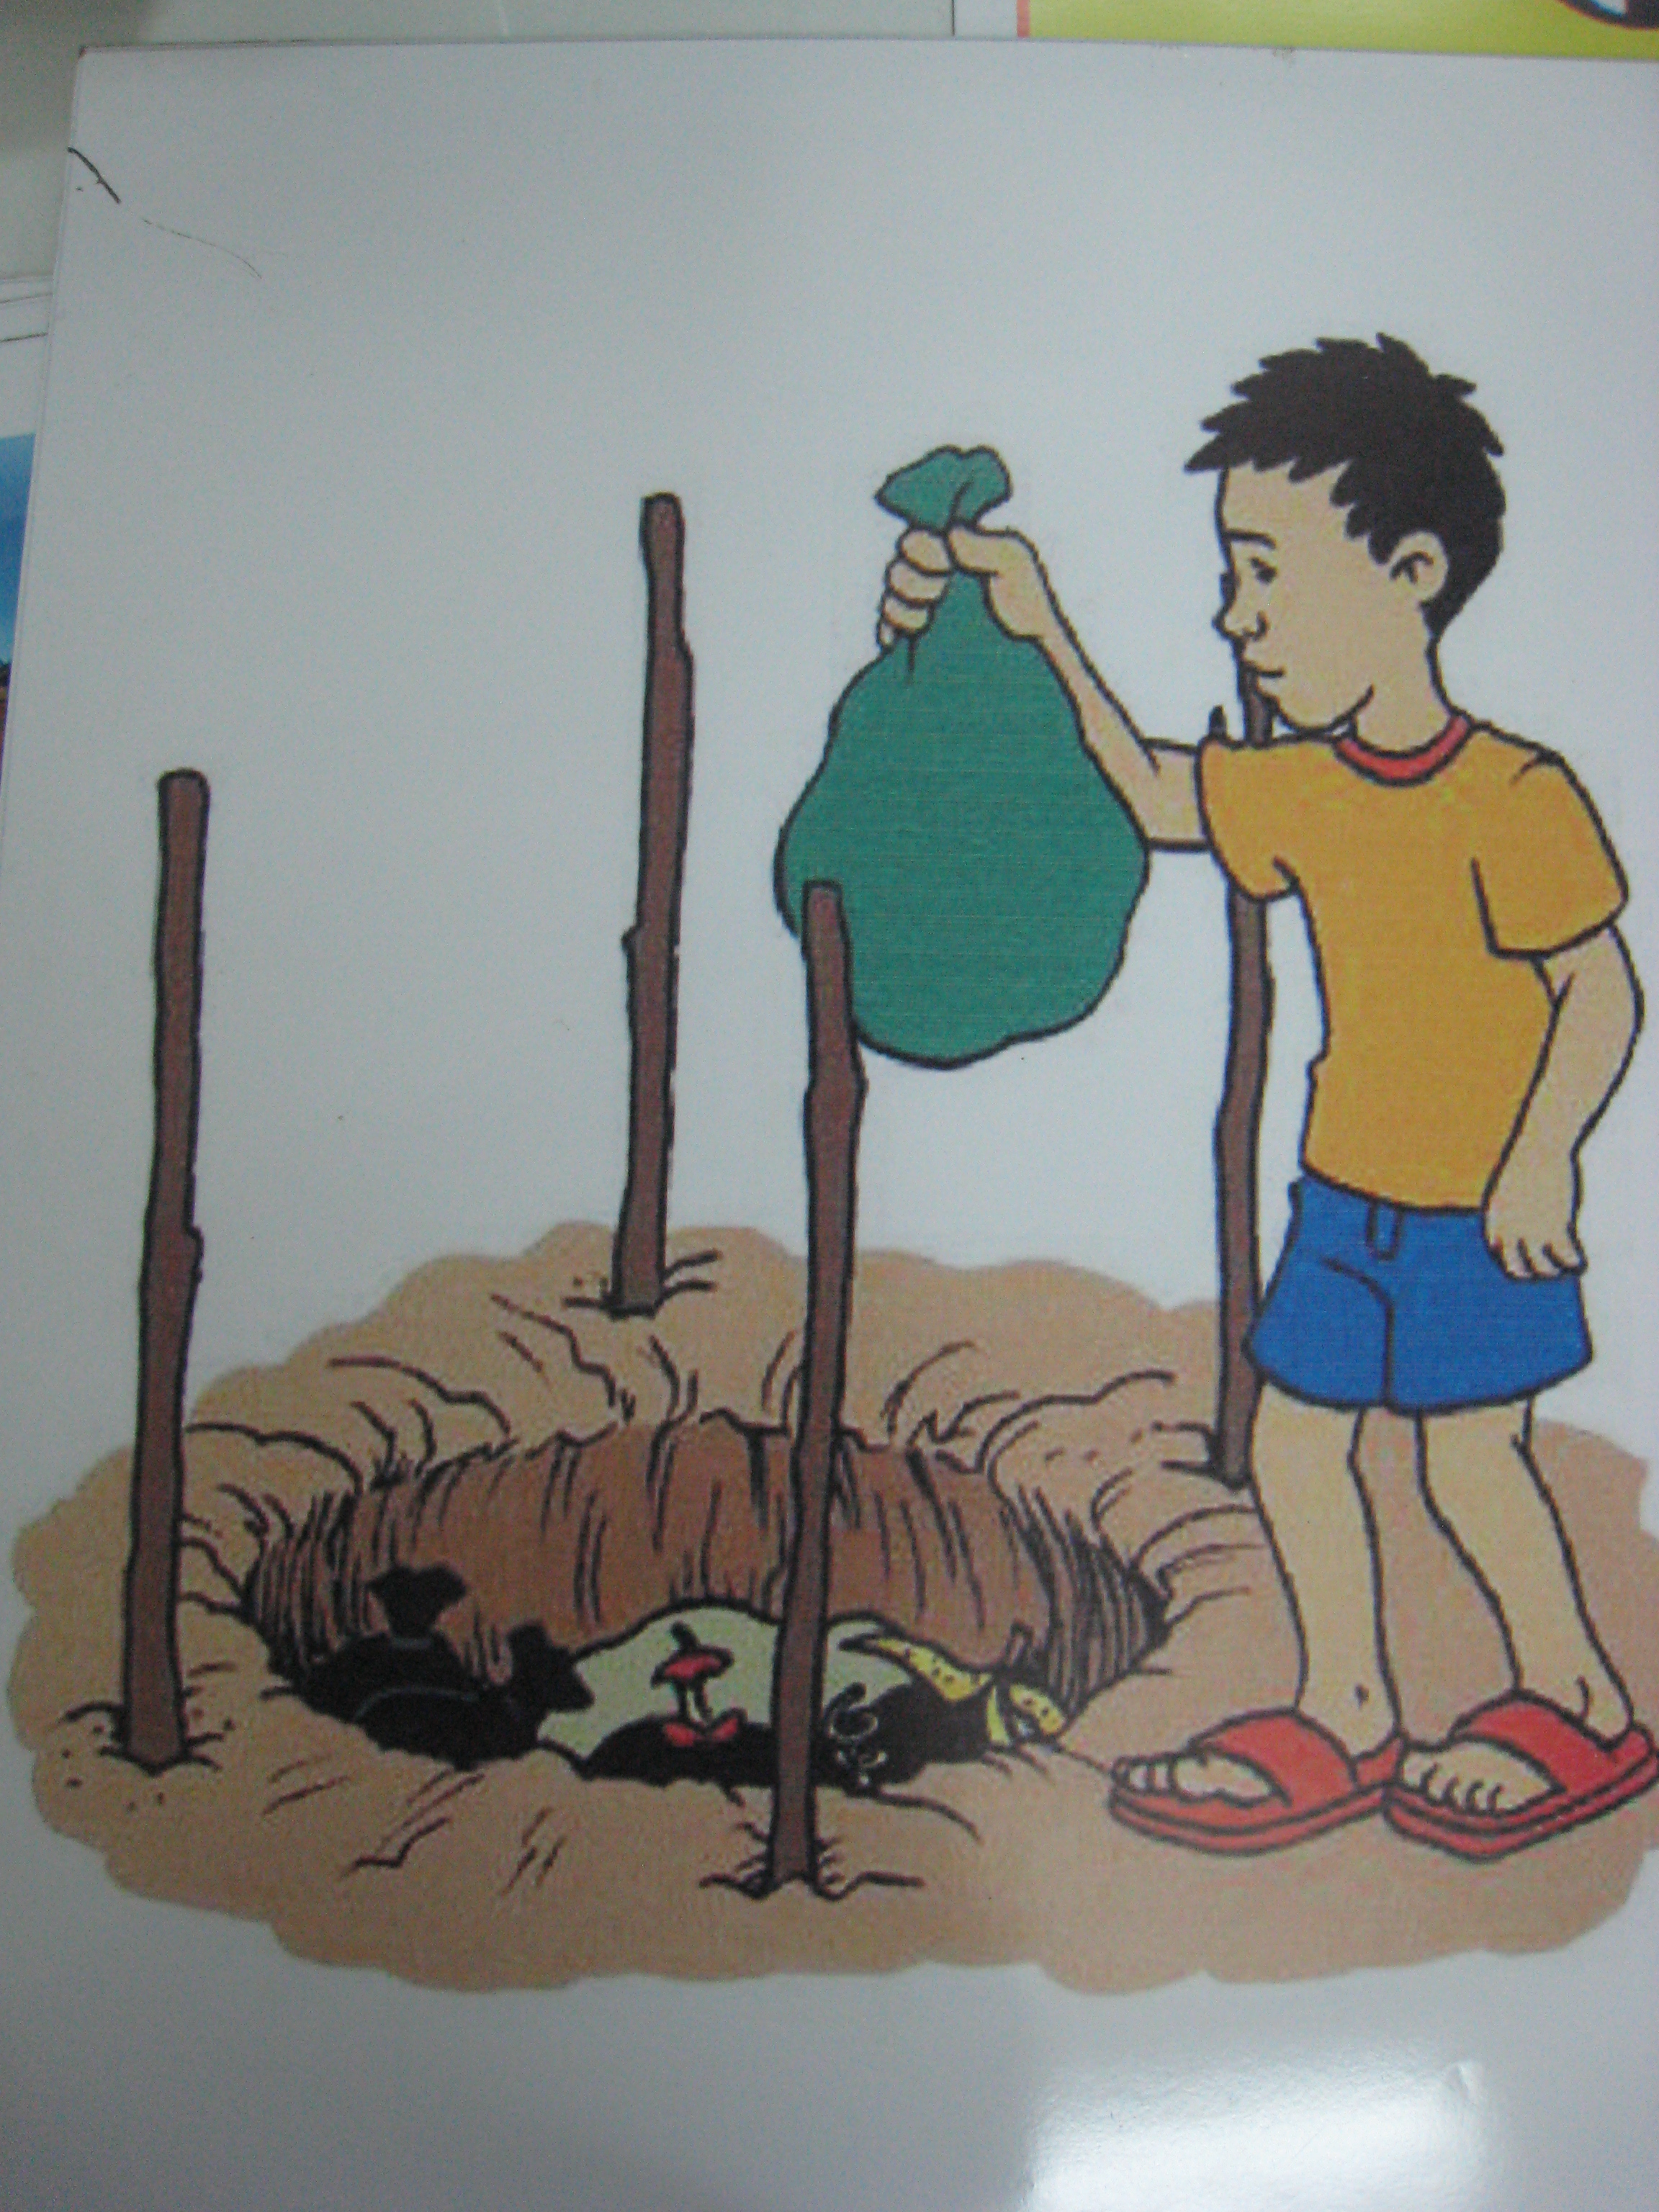
or

- dispose waste in designated public or private disposal places

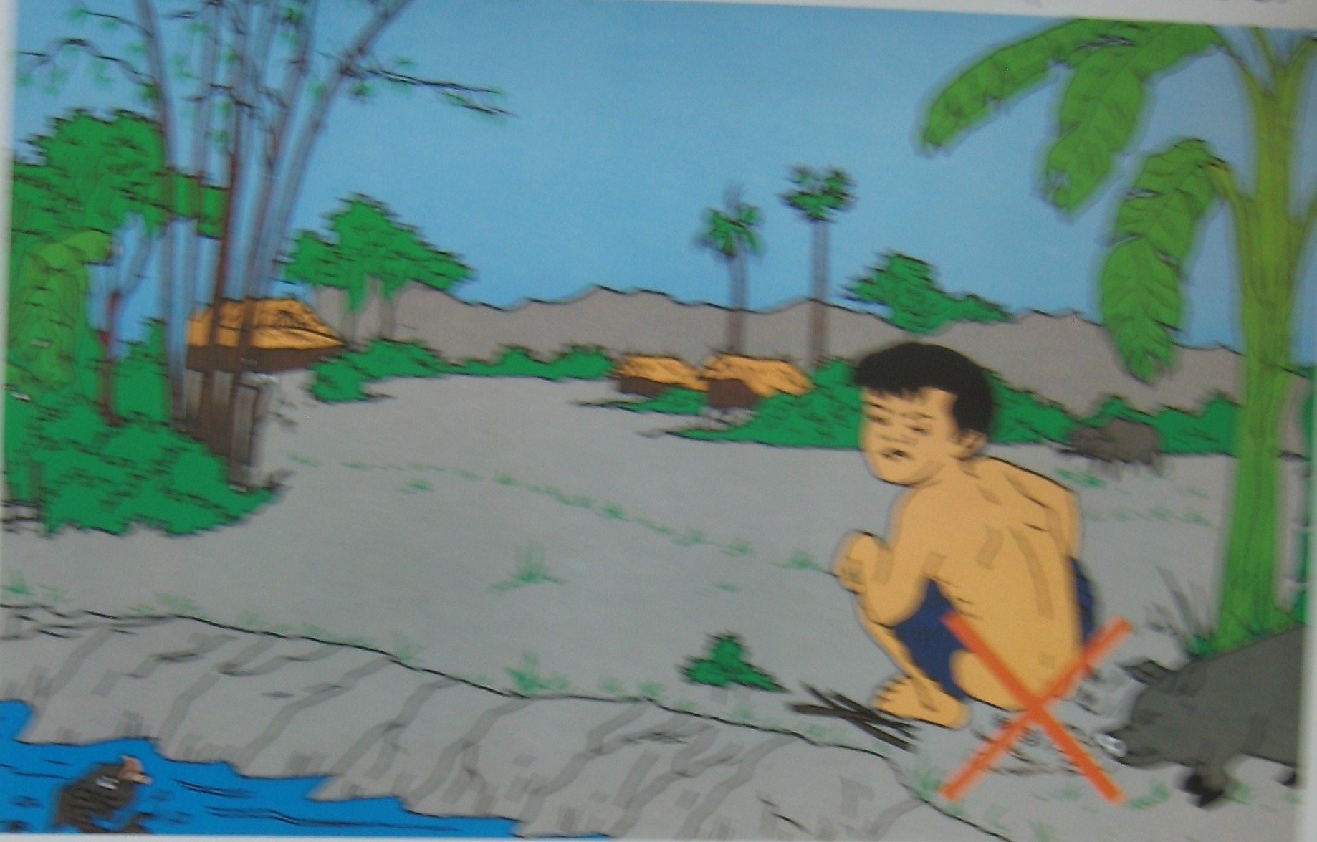

- do not defecate in the nature
- do not defecate into the river

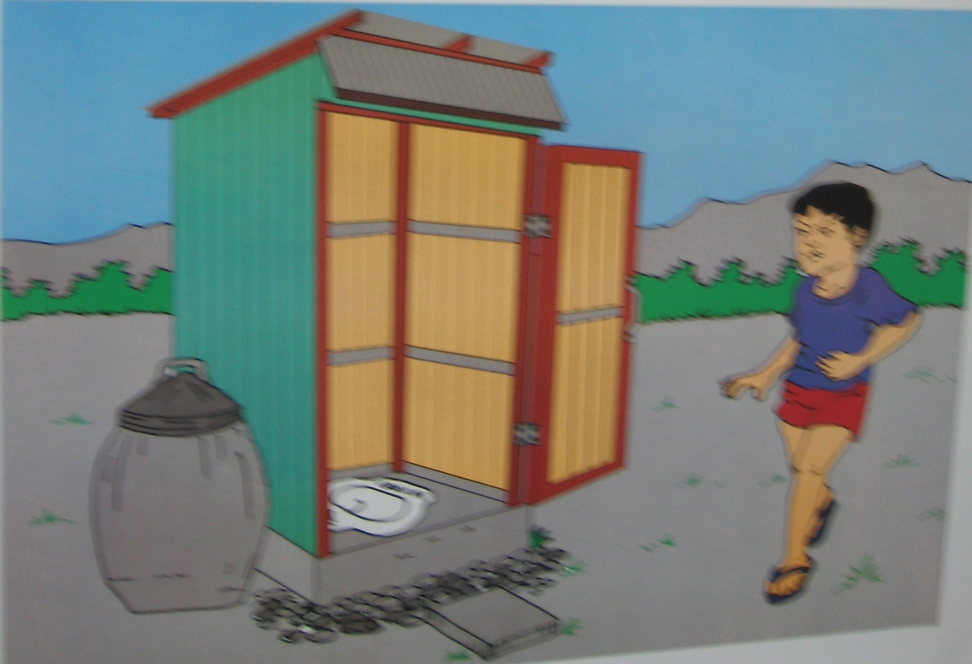
- use latrine
- clean latrine after using
- wash the hands with water and soap every time after defecating and urinating

