3rd SOUTH-EAST ASIA YOUTH NETWORK MEETING

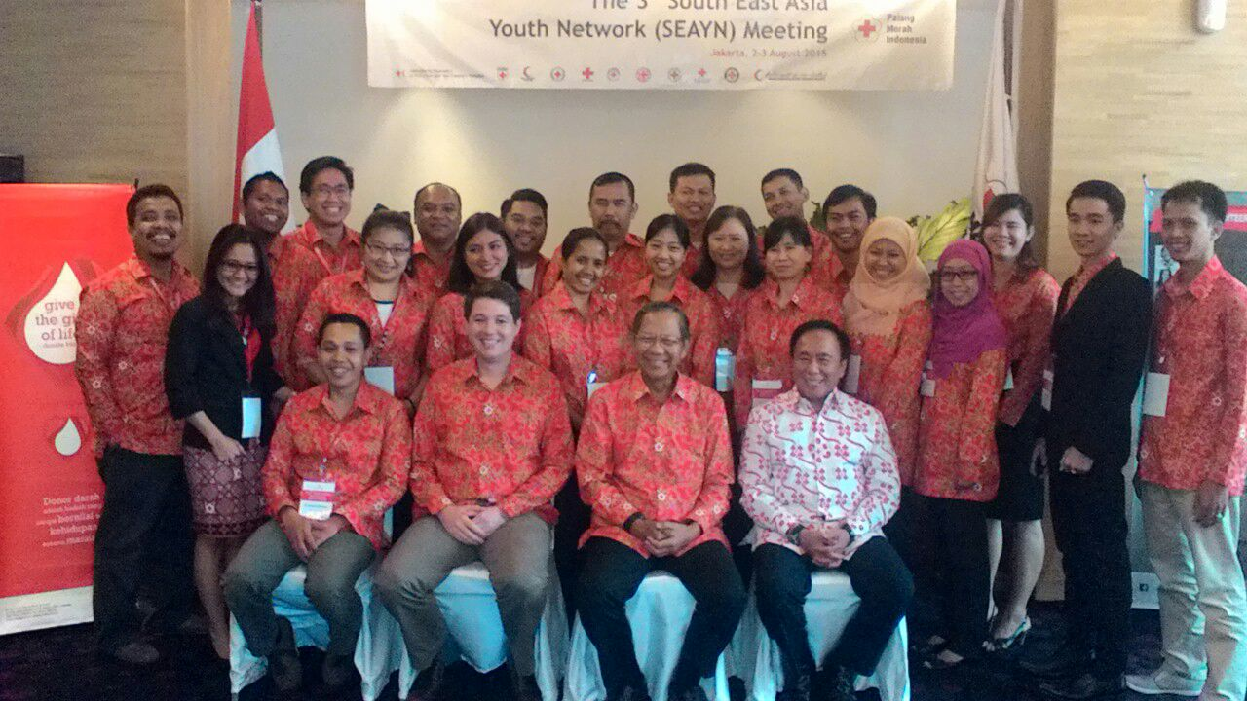

August 2-3, 2015
Jakarta, INDONESIA
1. Introduction

The South East Asia Youth Network(SEAYN) was developed as a sub-network linked to a zone-wide APYN in May 2013. It has a special characteristic as a youth network by ensuring equal participation of NS staff and Youth leaders in it. By nominating their NS youth staffs and youth leaders (volunteers) to be members of the SEAYN, each NSs in the SEA region follows the SEAYN terms of reference which was officially endorsed by the Southeast Asia Leadership Meeting held in Singapore in March 2014.

The SEAYN aims for enhancing NS service delivery by mobilizing the resources of youth in the region and by developing the regional youth action in the aspirations for positive change. It nominates its Coordination Team in the Network and develops its action plans to allow for SEA National Societies to strengthen youth and to encourage youth initiatives through the SEAYN, while also building capacity to extend peer to peer support among the SEAYN.
SEAYN conducted its first meeting in August 2014 in Phnom Penh, Cambodia where five National Societies (NSs) attended the meeting. The second meeting was held in Singapore in December with the attendance of 11 NS youth leaders as a response to the Beijing Call for Innovation adopted in the AP regional conference in Beijing, October 2014.

Following the Terms of Reference of Southeast Asia Youth Network, the 3rd SEAYN annual meeting is held in Jakarta, Indonesia hosted by the SEAYN Chair and Indonesia Red Cross Society (locally known as PMI or Palang Merah Indonesia) with the part of funding support from the CSR unit, IFRC SEA regional delegation and has been followed by the 2nd CSR Forum.

The meeting has reviewed about 2014-2015 activities, briefed about the upcoming events such as world humanitarian forum and International conference for further better engagement and developed 2016 action plan looking at issues of Youth in each NS programming and by considering each NSs’ expectations and commitment to SEAYN for their youth engagement and development. The members also addressed the specific agenda “ Youth in DRR focusing on School safety” as a key main agenda through the presentations of CSR unit and developed its action plans how to engage youths into this programme. Finally in the meeting the 3rd Coordination Team members has been nominated and a successful handover from its predecessors be carried with the aim to represent the SEAYN as a whole and assume greater leadership and ownership of the Network.

Objective of SEAYN Meeting
To engage youth in a meaningful way in order to implement the SEAYN action plans in a close connection with the Beijing youth commitment and the Beijing Call for Innovation as well as in an integration approach to the CSR.

Time and Venue
August 2-3, 2015 at 101 Jakarta Sedayu Darmawangsa Hotel, Jakarta Indonesia.

Expected Outcomes of meeting
  - To enhance roles and responsibilities of youth practitioners and leaders thru commitment of action plans and in a response to the Beijing call for innovation.
  - To engage youths into the DRR Programme in a more effective way
  - To nominate and handover Coordination team to next team in a successful way.
  - To affirm the importance of regional RCRC Youth Network and “Youth-led and National Societies-owned” platforms

2. Opening Ceremony

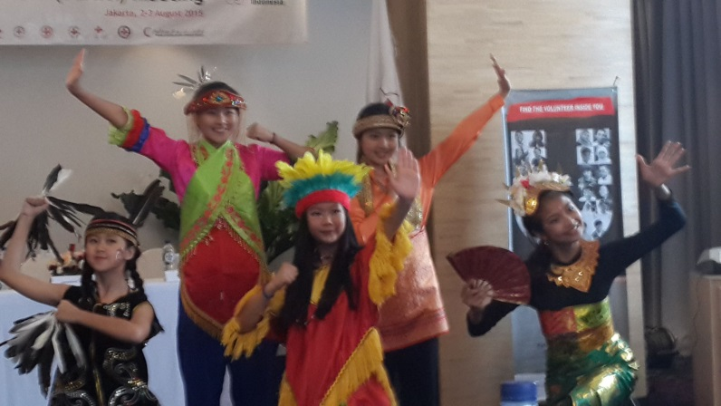
The 3rd SEAYN meeting was attended by 17 participants from nine National Societies: Brunei Red Crescent, Cambodian Red Cross, Indonesian Red Cross, Malaysian Red Crescent, Myanmar Red Cross, Singapore Red Cross, Thai Red Cross, Timor Leste (CVTL) and Viet Nam Red Cross. Indonesian Red Cross also invited participants from three chapters (Jakarta, West Java and Banten) as observers.

The PMI’s Executive Chairman, Prof. Ginandjar Kartasasmita accompanied by IFRC’s Disaster Risk Reduction Project Manager at South East Asia Regional Delegation, Herve Gazeau represented SEARD’s head of delegation, officially opened the meeting.

In his remark, Herve Gazeau said that youth programming should not be separated, but part of the programming (such as school safety). Red Cross Youth should understand the added value they have in social media as well as innovation, engagement, motivation and creativity. He also emphasized the strategic position Youth as agent of change that could contribute for community resilience. He welcomed SEAYN representatives to raise their voice in the upcoming SEA Community Safety and Resilience Forum, 4-6 August 2015 in Jakarta.

Prof. Ginandjar Kartasasmita recalled Youth as the backbone of PMI. Young PMI volunteers have responded to recent emergency response in the SEA countries and surroundings. He also underlined Youth/volunteer development is an investment in Red Cross Red Crescent quality service delivery.

The opening ceremony has been sparkled by the great performance of PMI Youth members Jakarta Chapter who delivered Indonesian traditional dances and “Dance of Life” for HIV/AID anti-stigma campaign.

Before started the meeting, participants shared their expectations for the 2 day meeting. Most of them expected the meeting as a learning and sharing knowledge forum to improve Youth activities in respective NS. Some of NS saw the importance of SEAYN to strengthen youth network within the region, encourage them in various humanitarian activities, and bring youth voice to global forum. There was also a need to discuss the sustainability of Youth to next step as Red Cross volunteers. All participants agreed that the meeting is a good opportunity to build better relationship and partnership among NS.

3. Global Update

Naomi Akamatsu (Youth APZ)
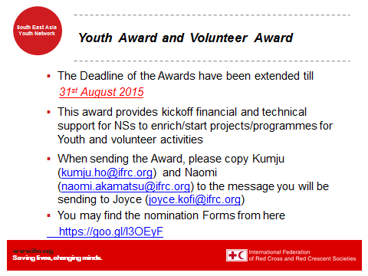
There was a presentation of upcoming events such as statutory meetings, youth and volunteer award, Global youth leadership toolkit collections, VIVA study 2016 project as well as HELP course. International Youth Day (August 12) was also emphasized to celebrate in a meaningful way.

Pls find the attached Presentation slides

4. Review of SEAYN action plan and activities 2015

Mohammad Zaidi (Co-Chair SEAYN)
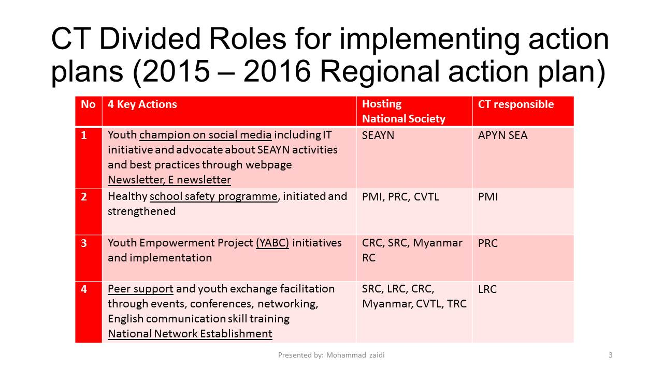In general, the SEAYN through online meetings has been so far successful, mostly engaged, and getting stronger. National Societies is encouraged to start/set up a webinar depending on what theme they want to share/discuss.

There have been eight online meetings up till date with 10 participants on average for each online meeting. The online meeting provides a great platform for information dissemination, sharing and discussion from members.

Challenges | What to do | Who | When | How
Advocacy | To develop SEAYN Newsletter and circulate all leaders and Programme people by SEAYN members | Focal; Zaidi, SRC  Marlouize, PRC  Khamla, LRC | Four monthly  End of Feb before the NS leadership meeting, First Edition | -Design paper  -Collect information and pictures  - Compile and edit  -circulate to all members
Innovation | To develop a Country level online webpage for Country Youth Activities (in local language and English translation) and share with all members about link | All members | End of Jan  Constantly update on bi monthly basis | -Design page  -Collect information and pictures  - translate in English and share the link
 | To develop a SEAYN online webpage/site thru Facebook and share with all members about link | Focal; Zaidi, SRC  Marlouize, PRC  Khamla, LRC | End of Jan  Constantly update on bi monthly basis | -Design page  -Uploading Newsletters and Collect info from country level pages  - Compile and edit  - share the link
 | To create chat-box by using APPs, line and skype. | Focal; Marlouize, PRC  Zaidi, SRC  Khamla, LRC | First week of Jan | -Contact list and send an invitation to all members
 | To organise the online meeting on bi monthly basis among CT members and all | CT members with chair | Time:3PM  Date:  CT: last Tuesday of 1st Month  First meeting on Jan 27  All: First Tuesday of 2nd Month  First meeting on Feb 3 | -Webinar  - Agenda discussion thru chat-box  - confirmation in the CT official meeting
Another initiatives;
- Establish working group to support SEAYN by including Governance in Governing board
- Bringing back SEAYN Action plans to NSs and interaction with Governing Board
- Invite guest of honours to Youth events such as music and dance performances

Newsletter
To date, SEAYN have produced two edition of 2-page SEAYN newsletter in print/PDF & e-newsletter format. The frequency of newsletter publication is every four month with four sections in its content:
- Youth Updates! It will reflect highlights from SEAYN and the Region
- Youth Speaks! Features short interview of few Youths within the region
- Youth Leads! will contain reflections, comments of SEA NS Youth events
- Youth Actions! features Youth news from 11 NS in the region

All articles in the newsletter are credited to the the SEAYN member/Youth from any NS who write the stories/articles. The SEAYN focal point select updates from NSs and summarize them in the newsletter.

In the future, SEAYN expect to have more articles and update to feed the SEAYN’s webpage and Facebook page.

Facebook
SEAYN has its Facebook at http://www.facebook.com/RCRCSEAYN. This page linked to the APYN page. The SEAYN FB Admin team channel all updates (articles, photo) from NS to the FB and upload them to the FB every Saturday evening.

Ad-hoc posts can be done that shares links from:
    - Various NS youth Facebook posts or articles
    - APYN Facebook Page
    - IFRC Facebook Page
    - YABC Facebook Page

Blog (Dynamic)
- SEAYN will also use blog to display the activities from various NS
- Weekly update on Saturday morning to feed to Facebook in the evening
- Projected to be created by August 2015

Webpage (Static)
- A one page official webpage that provides a one stop information on SEAYN & its members
- Links to the SEAYN Blog and SEAYN Facebook page + respective NS Facebook page and Blog
- Projected to be created by August 2015

Challenge on Youth programme faced by NS
- Increase the number of volunteers and retention of volunteers (youth turnover after job)
- Peer to peer education of YABC
- Upgrade youth policy, national network
- Advocacy to programme people and leadership, programme integration
- How to keep motivational for youths
- No funds and connection to programmes
- Development of enjoyable activities for the RC Youth.
- Inclusion of education curricular
- Social media technology
- Online meeting webex use, Facebook
5. NS Youth update (plans and challenges)

All participants

NS | Plans | Challenges
Brunei | - MIRACLE project youth volunteer will visit a specific ward of kids suffering from a disease e.g : cancer, and have a one day activities with them by asking what are their (the kids) dream. The youth volunteer and the BDRCS itself will try to fulfil their dreams, e.g : going to a theme park, riding horses.  - YABC | - Change of structure in the organization  - How to sustain and increase the number of youth  - Ideas on what kind of programme that youth are interested in  - How to increase the communication between the people who have position in BDRCS and the youths who have registered as well as the volunteers.
Cambodia | Continuing the YABC trainings | Difficulty to accessing webinar, so far using Federation office connection.
Indonesia | - Healthy school supported by Singapore RC and private corporates (national bank, corporates) in around 200 schools, 10 provinces. | No.
Malaysia | - Youth camp in Johor.  - Finalising youth policy end of this year.  - Conduct YABC in September/October. | - Limited funding from government.  - Youth cadet are mostly under Ministry of Education
Myanmar | - RCV/RCY Outstanding Youth Camp  - Youth Leadership Camp  - Youth and Volunteer engagement  - To engage more with other nation-wide youth network  - Membership driving from youth to elder retired person  - IHL for youth integrated in school curriculum. | - Generation gap between senior RCV and youth  - Difficult to retain RC: Nature of Youth, Youth interests, Competition for career development, No space for potential youth, Limited budgets for youth development
Singapore | - Support PMI in their Healthy School Safety programme (SPLASH OHP) : October 2015 to Batam, December 2015 to Banda Aceh  - Co-facilitation YABC in BDRC  - YABC Peer Educator training in SG  - Peer-to-Peer Youth Symposium 2015  - RCY Staff/Vol exchange (planned) with TRC | No.
Thailand | - ToT in FA, and IHL.  - Youth RC contest (Mr. and Ms. Youth RC/YRC ambassador), once in 2 year to promote RC affairs.  - Increase English capacity with Singapore RC | - How to increase the number of volunteers.
CVTL | - Youth camp  - Expand school program to another Municipalities  - Continue Youth healthy training to Volunteers in 13 Municipalities  - Continue Youth healthy training to ICBRR target in village.  - Continue Youth Leaders Meeting and Youth board member  - Tabacco campaign and Road Safety | - No funds for maintenance tools such as music  - Low internet access connection  - Communication media( feedback)
Viet Nam | - Develop agreement with ministry of education for youth activities in DM  - Mangrove activity with Korean RC | - Youth activities can only be done during holiday.  - No module or manual for youth.

6. Thematic area discussion

A. Youth role and contribution to Community Resilience (Herve Gazeau)

The presentation focused on Youth in School Safety with three example of cases --- PMI, Myanmar and CVTL. Based on United Nations (UN) data, it indicates that 60% of the world’s youth population, which is 750 million young people aged 15-24, are in Asia Pacific. Children and youth are especially vulnerable in disaster situations and face particular risks to their health, psychosocial well-being, protection, access to education as well as nutrition.

IFRC focus to involve children and Youth into the resilience programme through what they call as School Safety. The basic reasons to focus on this safety are:
- On average, 230 schools are affected by disasters every month in Asia Pacific, affecting more than 275,000 children annually
- Working with and for children / youths has proven a very effective way to plant the seeds for a “culture of safety”.
- Engaging with them also enables us to reach their siblings, their peers, and the whole community

Three pillars have been identified to ensure the integration of Youth, through school safety programme, into resilience initiative as diagram below:

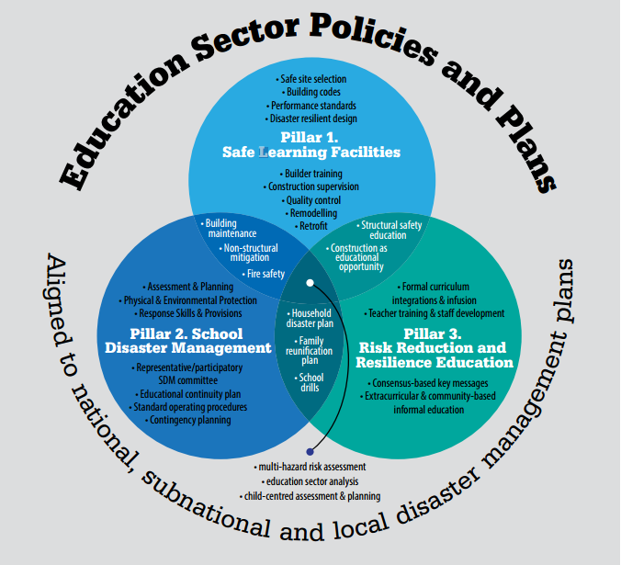

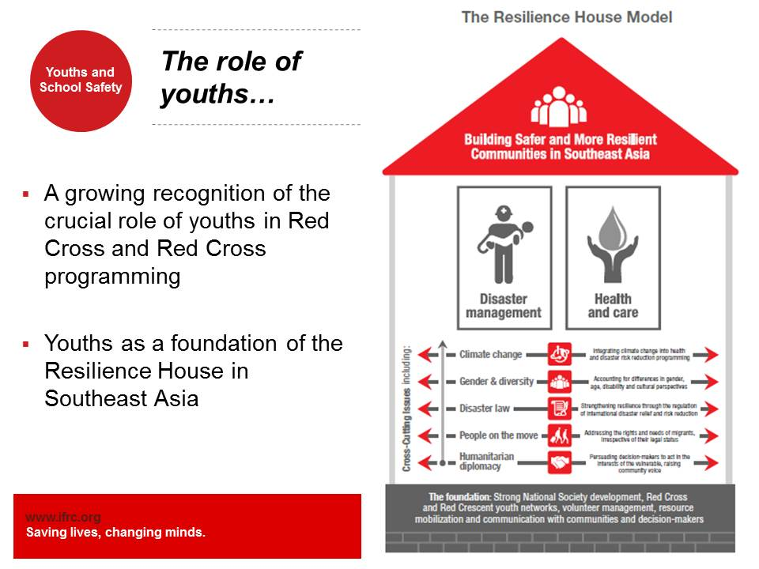
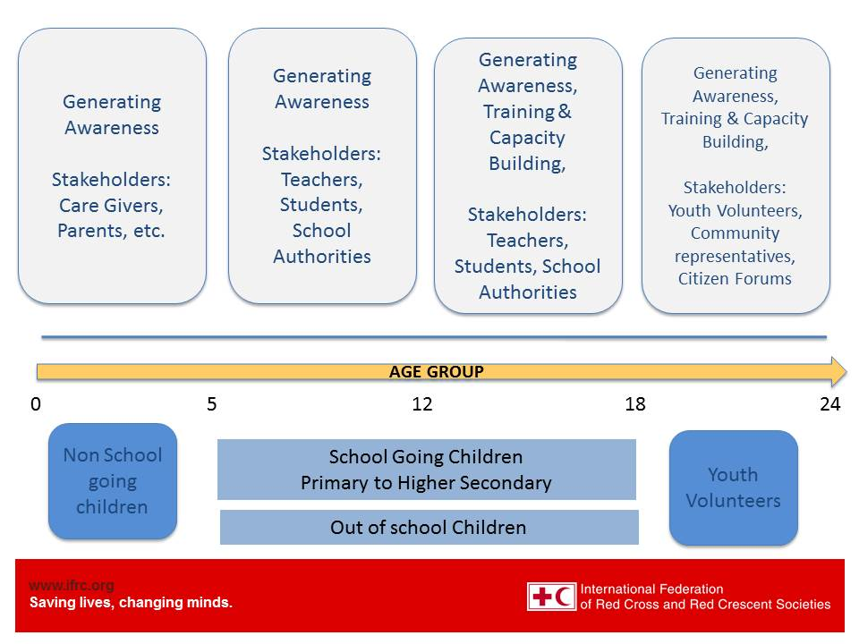

In this session, National Societies from Myanmar, Viet Nam, PMI and CVTL shared their experiences in school safety programme:

Myanmar: school based DRR through YABC.

Vietnam : safety school is implemented in cooperation with ministry of education, and training teachers

PMI : Cooperation with government, school committee, local agencies. School safety programme is implemented through several formats including disaster preparedness school (sekolah siaga), healthy school (sekolah sehat), and resilient school (sekolah tangguh).

CVTL : still advocating with ministry of education to recognize the curriculum by the government.

B. Youth as Agent Behavioural of Change (YABC) – Panel discussion; panellist from Cambodia, Myanmar , Thailand and Singapore
YABC updates | Challenges
Cambodia:  - Youth activities implemented in branches  - Youth needs more resources to support them.  Myanmar:  - Developing gender and diversity policy  - In the strategic plan, highlighting the youth involvement in DM and cross cutting issues  - Adapt the methodology of the module  - YABC Peer Educator Training, with 29 youth leader participants from Kachin, Kayah, Mon, Shan (South), Thanitharyi Region, Yangon (including SBDRR project  Singapore:  - Building confidence  - Championing on YABC by providing facilitators  - Able to integrate into existing program  - Implementation of new RC Youth Organization Structure to better support SRC Community Based Programme (CLARE)  - Increased from 4 districts to 5 districts  - Establishment of 2 RC Youth Club  - Club@NorthEast, Club@NTU Alumni  - Strengthen communications with teachers through school visits & Unit Officer Programme  - Stronger emphasis of Services and Values  - Linkamania, Project Humanite, WRCD, A&P, NFAC, CLARE, International Bazaar  Thailand:  - Recently done YABC Training.  - Integrating into Youth events including leadership, friendship and First Aid.  - Planning to extend more integrating into existing program | Less understand about YABC concept by branch government.  - There is no confidence from the leadership on behavioural change --- a huge generation gap between senior RCV and youth  - Difficult to retain RCY longer in RC (nature of Youth, Youth interests, competition for career development, no space for potential youth, limited budgets for youth development)  - Language barriers.  - Time constraint in delivering program  Language barrier

7. Nomination of 3rd Coordination Team

All 3rd SEAYN meeting participants

During dinner, all participants discussed on the SEAYN’s new coordination team (CT). The composition of existing CT is:
- Chair : PMI
- Co-chair : Mohammad Zaidi (Singapore RC)
- Deputy Chair : Lao RC
- Officer : Philippine RC

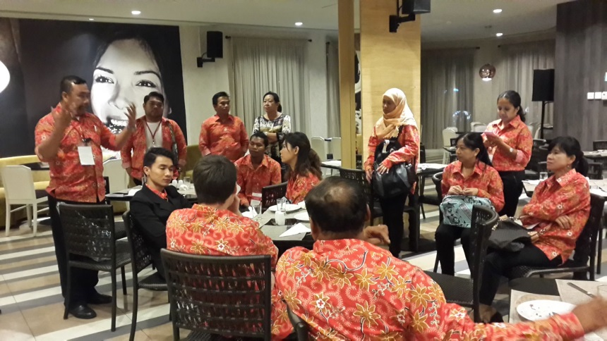
There were two options to select the new CT members. First, following the alphabetical order as agreed in ToR. It means that Lao RC will be the Chair, Malaysia RC as deputy and Phillippines RC as officer. Lao RC has informed IFRC their unavailability to be the SEAYN chair. Philippines RC confirmed their position as deputy while Malaysian RC at that time still could not confirm whether they are available for Chair position or not. Second option was to have election from participants who attend the 3rd SEAYN.

After some discussion, participants agreed to choose the first option following the ToR. Malaysia Red Crescent agreed to accept the Chair position. Azmi Tajuddin, the representative of Malaysian RC will share this decision to the MRC leadership and later appoint someone in charge in the position.

The CT composition will be:
Chair : Malaysian RC
Co-Chair : M. Zaidi (Singapore RC)
Deputy : Philippines RC
Officer : Singapore RC

8. SEAYN Action Plan 2016 and “Working better”

All participants wrote individually about action plan 2016 and how to work effectively in SEAYN

A. Action Plan 2015-2016 and indicators
- Advocacy of SEAYN; development of SEAYN Case study with good practices of NS Indicators: PMI, Myanmar, VNRC, SRC, BDRC, CRC (TBC)

- Youth champion on Social media including IT initiative and in humanitarian action and promotion of RC learning platform
Indicators: 11 NS establish of national webpage/facebook, # of increase of learning platform users

- School Safety (SBDRR- child friendly) tool incorporated into existing programme) /continued in ALL NSs and strengthened
Indicators: MalRC, PMI (review), SRC, CVTL (review), BDRC, MyRC (Discussion)

- Youth Empowerment Programme initiatives (YABC, leadership training, involvement of youths in policy development, Non Violence and peace programme)
Indicators:
- YABC (MalRC, PMI, CVTL, VNRC, BDRC,PEs as coF- SRC-MyRC-TRC)
- Leadership training (MyRC, PMI,MalRC, SRC,VNRC, BDRC).
- Non Violence Programme (PMI, CVTL, Thai RC, MyRC—review, BDRC)

- Peer support and youth exchange facilitation thru webinar, events, conferences, networking, capacity building for members for the development of Y and V
Indicators: MalRC - annual meeting, 11 NS invitations to their national events, deployment of members to some trainings thru support of IFRC.

B. How to engage better to SEAYN
- Build communication channels.
  - Social media platforms such as Facebook to be constantly updated and actively engaged in through an agreed mechanism by SEAYN members
  - Invite other youth members/volunteers (youth leaders from branch/chapter/province) to the webex
  - Case study or lessons learnt from each NS Youth programmes.
- Sustaining SEAYN by:
  - Circulating letter from IFRC to NS secretary general of each NS about the CT nominations and SEAYN meeting
  - Committing to an annual Face-to-Face meeting hosted by chair
  - Setting up communication team in SEAYN
  - Designing SEAYN Logo for better identity and recognition

9. Commitment and recommendations to Leaders and CSR

All participants
Participants of the 3rd SEAYN meeting collectively produced a commitment to Red Cross Red Crescent leaders within the region and to SEA-CSR forum which will be held on 4-6 August 2015.

Commitment to CSR and SEA Leaders:

- Use of innovative technology to promote and advocate Red Cross Fundamental Principles and Values in all involvement of programmes and address thematic issues into constructive solutions;
- Implement the SEAYN Action Plan 2015-2016 with all efforts and by all means and incorporate youth development component into NS Strategic planning;
- Incorporate into existing/initial school safety programme by provision of child-friendly tools and trainings for children and youths;
- Promote and advocate RC Community Safety and Resilience activities among youths and adults through online meetings, case studies, and newsletter development;
- Facilitate peer to peer support and cooperation between 11 NSs through enhanced youth policy, strategy and youth empowerment programmes under CSR.

At the same time, SEAYN members also urge leaders and CSR forum participants to:
- Endorse and Support SEAYN to fully implement action plan 2015-2016;
- Create enabling environment by allocating resources (finance, technical, materials) for youths and volunteers to involve in assessment, planning, monitoring, evaluation and reporting of CSR programmes in an integrated and meaningful way;
- Certify and qualify youths to be trainers and experts in technical parts; DRR, CCA, CBHFA and YABC, for better ownership of the programmes.

10. Closing and conclusion

The 3rd SEAYN meeting has successfully reached several important results to follow up. This is also a meeting with the most complete participants joined together from nine SEA countries (with only Laos and Philippines could not join the event).
All participants enjoyed their participation in this meeting. The dynamic and spirit among participants are always at high level in a very tight schedule. Participants also expressed their high appreciation to the Indonesian Red Cross for their hospitality to host the event. two day meeting has been successfully produced several great documents.
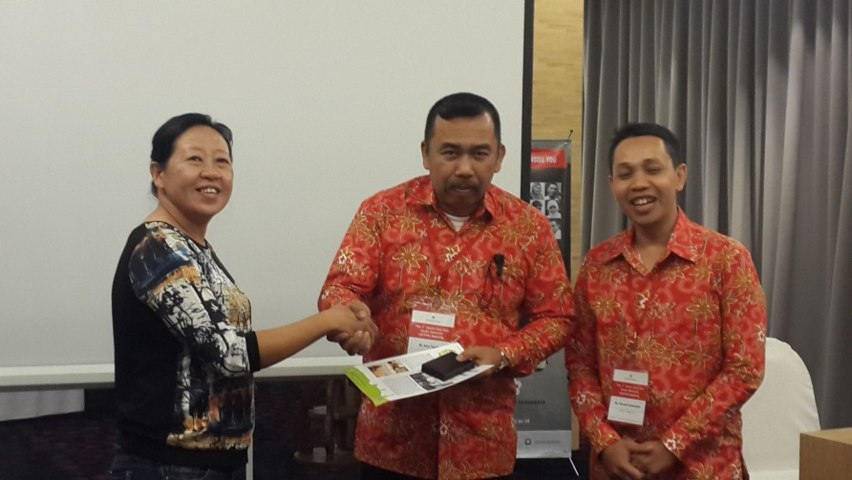
Before closing the meeting, PMI represented by its head of Youth and Volunteers Division, Exkuwin Suharyanto and accompanied by his predecessor, dr. Lilis Wijaya officially handed-over the chair position of SEAYN to Mr Azmi Tajuddin from Malaysian Red Crescent. Azmi emphasized Malaysian Red Crescent’s commitment to lead the network and ask for all SEAYN members support.
The 3rd SEAYN meeting concluded its session with a great farewell lunch at the artistic Plataran Resto, South Jakarta.

Annex 1: Meeting Agenda and Abbreviations

3rd South East Asia Youth Network
August 2-3 2015. Indonesia
Agenda

Time (PM)  August 2 | Item | Presenter/facilitator
2.30-3.30 | Welcome  Opening Speech  Agenda briefing and introductions | - PMI board member/ Hosting Chair  - IFRC regional office
3:30-5:00 | - Global Updates (statutory meetings, regional cooperation)  - Review of SEAYN Action plan and activities  (Q and A)  Working Tea break | - Naomi, IFRC AP zone office (10mins)  - Mohammad Zaidi, Co-Chair (10mins)
5:00- 7:00 | 3. NS Youth Updates  - 2014 - 2015 Youth activities and 2016 Youth Plan  - Focus on Successes and Challenges  - Q and A | 5 Mins x10NSs  - Brunei  - Cambodia  - Lao  - Indonesia  - Malaysia  - Myanmar  - Singapore  - Thailand  - CVTL  - Vietnam
7:00-8:00 | 4.1 Thematic Area discussion  - Youth role and contribution to Community Resilience  - Focus on Youth in School Safety (Example cases --- PMI, Myanmar, CVTL)  - Q and A | - Herve Gazeau  - PMI  - Myanmar  - CVTL
8:00-9:00 | Welcome Dinner  - Official Handover to New Coordination Team  - New CT members commitment (Speech) | - PMI Chair to New Chair and its team
9:00-10:40 | 4.2 Thematic Area discussion (Panelists)  - Peer support and YABC motivation  - YABC experiences and challenges  - Integration into programme | - Cambodia  - Singapore  - Myanmar  - Thailand
10:40-11:20 | 4.3. Thematic Area discussion (Presentation and Group Discussion)  - SEAYN profile and ownership  - How to use SEAYN facebook to collect Newsletter information  - How to coordinate Members engagement, Working systems, link with APYN, communication focals | - Co chair and All
11:20-11:30 | 5.1 Development of Action plan 2016  - Any other thematic areas (VP, Gender, Migration, CC,)  - Individual commitment and challenges  - Group discussion based on individual plans/prioritizations | All  - Individual ideas  - Group summary
Time (AM)  August 3 | Item | Presenter/facilitator
8:00-9:00 | 5.2 Presentation of Action plan 2016, Summary  - Recommendation to Leaders and CSR Forum | - All
9:00-11:00 | 6. Commitment Pledge development  - Finalization of action plan 2016, commitment  - AoB  - Departure of some members | - Co-chair and IFRC regional office and All
11:00-12:00 | Farewell Lunch | - All

Abbreviations
APYN | Asia Pacific Youth Network
APYS | Asia Pacific Youth Summit
CCA | Climate Change Adaptation
CT | Coordination Team
CSR | Community Safety Resilience
CVTL | Cruz Vermelha Timor Leste (East Timor Red Cross)
DRR | Disaster Risk Reduction
NS(s) | National Society (ies)
PMI | Palang Merah Indonesia; Iocal name of Indonesian Red Cross
SEAYN | South East Asia Youth Network
Y.E.S | Youth Engagement Strategy
APYN SC and CC | Steering Committee, Coordination Committee
ToR | Terms of Reference
YEP | Youth Empowerment Project

Annex 2; National Society Youth calendar with 2015 Plans

IFRC SEA office added and completed a list of respective 2015 NS youth plans and calendar by incorporating all ppp slides from youth leaders and by communicating with other members

No | Country | Plans/Calendar 2015
1 | Brunei | - Youth Policy Update  - FA accreditation system for Youth volunteers  - YEP initiatives (TBC)
2 | Cambodia | - Capacity building for youths and volunteers in terms of leadership skills and YABC  - Culture of sharing project expansion  - Resource mobilisation and Fundraising for youth project  - My RC story and voice of youth campaign, FP promotion and HV  - Exchange between JRC and CRC
3 | Indonesia | - National Youth Gathering (possible invitation of network members), 2016  - Healthy Safe school project  - Social media for Youth
4 | Lao | - High school/University Youth network establishment both in capital and provincial levels  - Appoint youth leaders in schools and elect the RC youth ambassadors as well Youth leaders in villages  - Training: Disseminators FA (Free and Commerce)  - Data base: develop, collect youth data and compile into one  - Initial development of the Youth Policy, Guide lines and strategy and expected approval by the end of 2015.
5 | Myanmar | - Junior Youth Project start- Jan- Dec  - Integrated Youth empowerment through Community based Projects/program.( Jan-Dec2015)  - Youth’s need assessment visit- Feb  - YABC Training – March or May  - RCV outstanding camp ( including RCY)- May  - RC Youth leadership training- Oct  - Exchange Program ( Oct- Dec)
6 | Philippines | - Capability Building for Leadership Development Program (Youth Instructors’ Training Course) – three times per quarter  - Implementation of Healthy Lifestyle and Prevention of Lifestyle Diseases Program  - Mainstreaming YABC Approach  Calendars;  - Jan- Feb; 1ST Chapter Youth council presidents conference  - March-Apr: chapter visits by area coordinators  - May; 4th National Youth Council Executive meeting  - June-Aug; IHL debaste for college RCY  - Sep; 5th NYC meeting  - Oct: 19th National Youth Congress and elections for new National Youth Council Officers
7 | Singapore | - Continuous Youth activities in chapters  - New initiatives; opening new chapters (Entrants, RC clubs, Alumni)  - YES Promotion  - CLARE Project with YABC,  - Leadership programme  - SPLASH Project
8 | Thailand | - First Aid Training in 5 camps  - Annual FA competition on Aug 12  - Learn English initiative in English camps  - Social media  - YABC Training (TBC)
9 | Timor leste | - Targeting young people for training healthy life style with tobacco banning  - Youth Assembly in May 2015  - District Assembly in March and April  - School Youth Programme Module development by Oct

Annex 3; ATTENDANTS list of 3rd SEAYN meeting

No | Name | NS | Position
1 | MS Adinana Norrasdiba Binti Haji Abdul Rashid | Brunei Darussalam RC | Assistant Youth Director
2 | Sam Kosal | Cambodian RC | HR and Youth Director,
3 | Roeut Sokhon | Cambodian RC | Youth coordinator
4 | Ms. Vidiana Xareal | CVTL | RC Youth Coordinator
5 | Mr. Vicente da Silva Antonio | CVTL | Deputy of Youth
6 | Exkuwin Suharyanto | Indonesia | Head of Youth & Volunteer Division
7 | Doddy Alfitra | Indonesia | Head of Subdiv Youth Development
8 | khamla | Lao
9 | Azmi Tajudin | Malaysian RC | OD/Youth field officer
10 | Yusrizan Usop | Malaysian RC | Youth representative, National OD committee member
11 | Ms. Hnin Phyu Phyu Myint | Myanmar RC | Youth/CAS coordinator
12 | Mr. Min Htike Aung | Myanmar RC | Youth representative,
13 | Ms Edlynna Tan | Singapore RC | Youth Executive officer
14 | Mr.Mohammad Zaidi | Singapore RC | Youth Council leader
15 | Ms.Sunisa Nivesrangsan | Thailand RC | Deputy of Youth bureau
16 | Mrs.Penprapa Kesornmala | Thailand RC | Youth officer
17 | Ms Vu Thi Phuong | Vietnam RC | Deputy HR/Youth director
18 | Kumju Ho | IFRC SEARD | Youth and Volunteering officer
19 | Herve Gazeau | IFRC SEARD | DRR project manager
20 | Florensia Malau | IFRC Indonesia | OD coordination manager
21 | Ahmad Husein | IFRC Indonesia | Sr NS Development & Comm manager
22 | Tri Priyanto | PMI HQ | Staff on Youth Programme
23 | Neni Ferdian | PMI Banten Chapter | Staff on Youth Programme
24 | Okta Riyadi | PMI DKI Chapter | Staff on Youth Programme
25 | Azis | PMI West Java Chapter | Staff on Youth Programme

