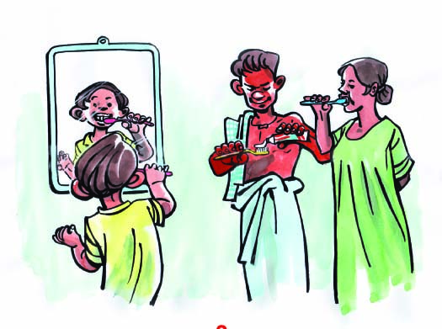
3. Personal hygiene

good behaviour :
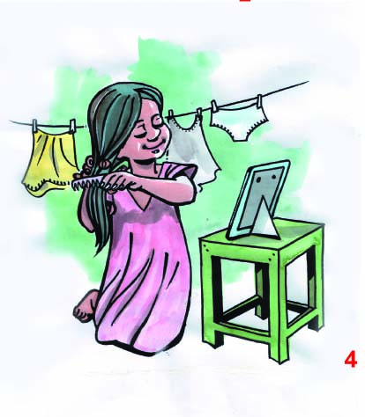
- brush your teeth with a toothbrush after meals and when you wake up in the morning

- change into clean clothes daily
- wash bed sheet, pillow and blanket often and lay them on the sun
- ​wear shoes
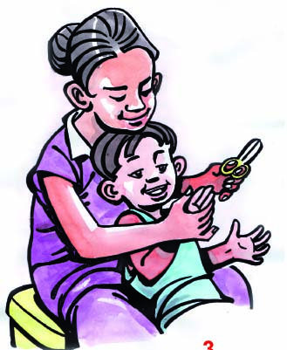
          - trim your nails and keep them clean

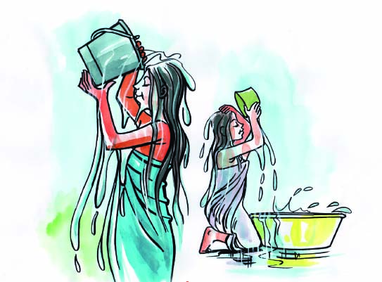

- take a bath with soap every day
- clean your body, hands, nails, and feet
every day

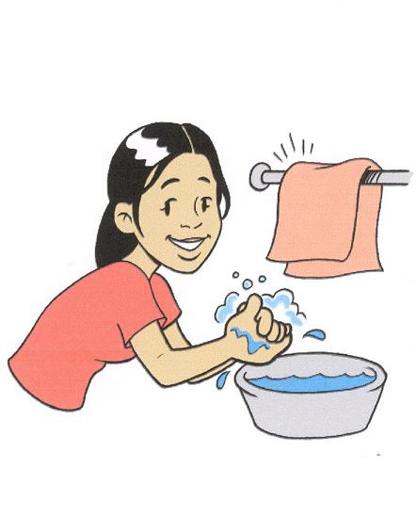
Hand Washing

Washing hands with water and soap:
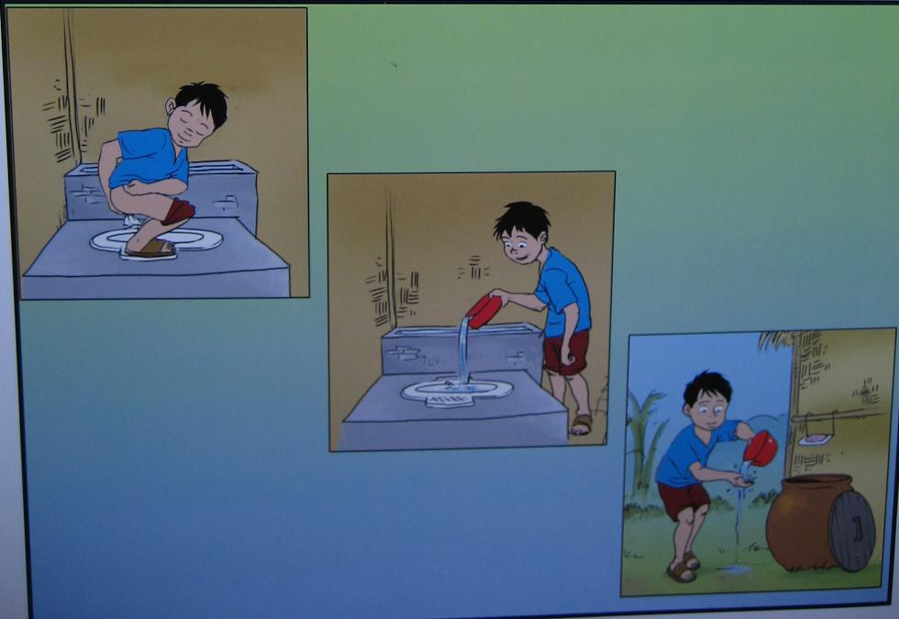

- after using latrine

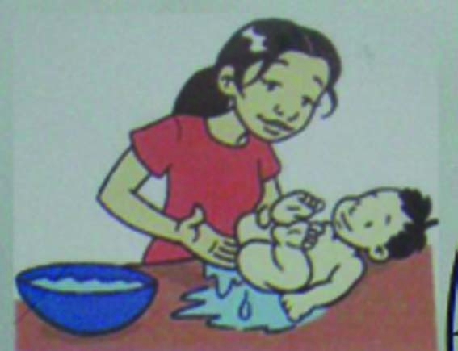

- after cleaning children
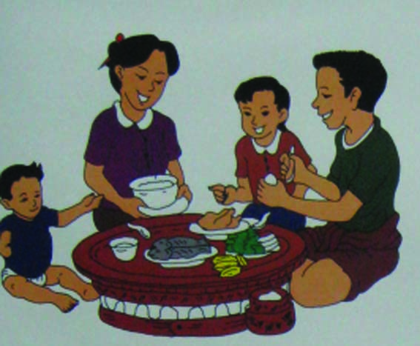

- before and after eating
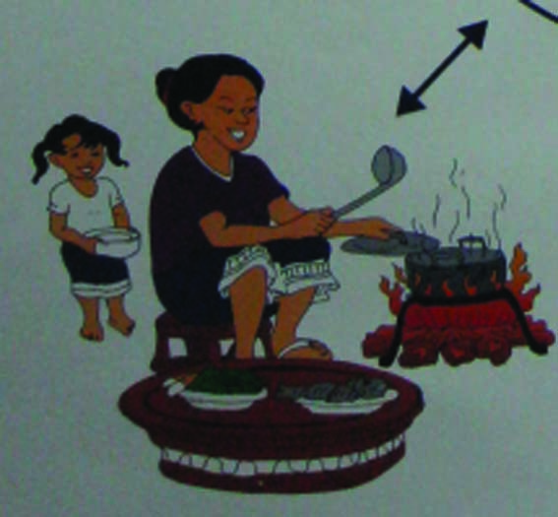

- before cooking
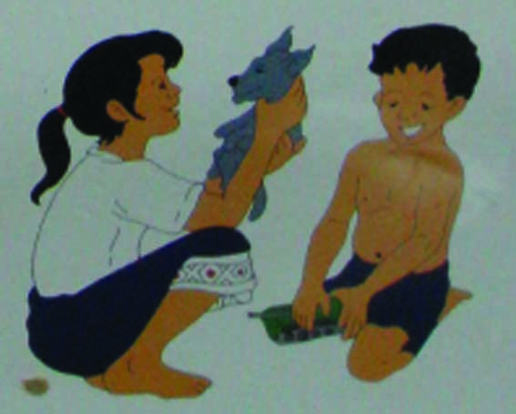

- after touching animals and dirty things

